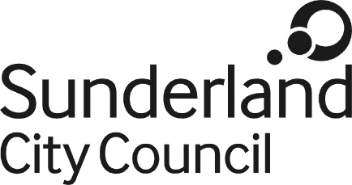

Business Energy Adviser
Grade 7 (SCP 26-30) £29,636 - £32,878
37 hpw, Fixed term for 24 months

Sunderland’s vision is that by 2023 we will be a connected international city with opportunities for all; our values are we innovate, we enable and we are respectful.
Sunderland City Council has exciting opportunities to join the Energy Service. You will be required to coordinate and deliver energy efficiency support and advice to Small and Medium Sized Enterprises (SMEs) in Sunderland as part of the Council’s Energy Storage and Efficiency project which is part funded by the European Regional Development Fund (ERDF).

You will be responsible for the delivery of energy audits, report production and engagement with businesses to develop an energy action plan to assist in the reduction of energy consumption and the realisation of financial and carbon savings. The role will also assist businesses in obtaining grant support for these measures from local, regional and national grant initiatives. The post holder will also be required to assist the Council’s Energy Services manager with the delivery of the wider Sunderland Energy Storage and Efficiency Programme.

This post is part-funded by the European Regional Development Fund, and the post holder must comply with the relevant publicity and monitoring requirements as necessary.

