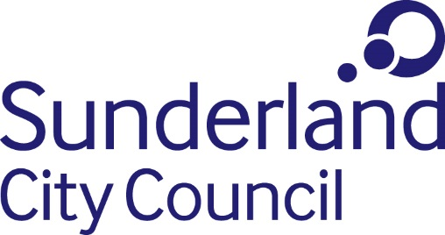
Job Description

Job title: Graphic Design Executive / Senior Executive
Directorate: People, Communications and Partnerships
Grade: Grade 2 / Grade 4 (Salary in accordance with experience)
Responsible to: Graphic Design Officer

Purpose:

- To support the Graphic Design Officer in protecting and enhancing the key brands of the organisation across marketing campaigns and materials.

Main Duties and Responsibilities:

- Design consistent and engaging publications and materials. Advise and support colleagues in terms of the best route to deliver against set objectives and provide clear timescales for delivery.
- Have a commitment to continuous professional development and take the initiative in staying abreast of latest techniques and trends in graphic design.
- Support the Graphic Design Officer as the custodian of council brands for the organisation through delivery of consistent and high-quality publications and materials.
- Develop new concepts and brands where required.
- Advise and support colleagues in terms of the most appropriate and effective routes to meet set objectives through graphic design.
- Manage workload against set deadlines.
- Take a proactive approach to personal development – using training opportunities to stay abreast of latest industry techniques and trends.
- Be a visible and collaborative team member, supporting the wider communications team across key projects
- To promote and champion a positive organisation-wide culture that reflects the Council’s values.
- Comply with the principles and requirements of the Data Protection Act 2018 and GDPR in relation to the management of Council records and information and respect the privacy of personal information held by the Council.
- Comply with the principles and requirements of the Freedom of Information Act 2000.
- Comply with the Council’s information security standards, and requirements for the management and handling of information; Use Council information only for authorised purposes.
- Carry out duties with full regard to the Council’s Equality policies, Code of Conduct and all other Council policies.
- Comply with the Council’s Health and Safety policy, rules and regulations and with Health and Safety legislation.

Comply with the principles and requirements in relation to the management of Council records and information; respect the privacy and personal information held by the Council.

June 2019

