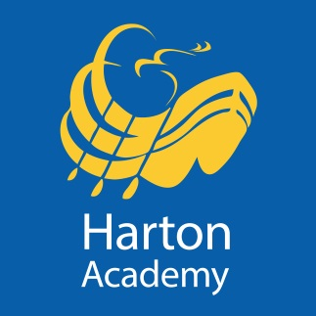
Harton Academy
Kitchen Assistant
£9.62/hr, 10 hours a week, Term Time only

We are looking for a motivated individual to join our successful catering team. You will work in the kitchen and the dining area, and assist with the food preparation and service of meals, as well as undertake dining hall duties and assist with service and equipment checks.

Your interpersonal skills will enable you to provide an excellent customer service to our students and colleagues, and ideally you will have an awareness or be trained in food hygiene.

We are committed to safeguarding and promoting the welfare of children, young people and vulnerable adults. We expect all our staff and volunteers to share our commitment. Successful applicants are required to obtain an Enhanced Certificate of Disclosure from the Disclosure and Barring Service.

Application packs are available from Harton Academy’s website - https://harton-tc.co.uk/year-7-11/information/vacancies/kitchen-assistant/ – and should be returned to Harton Academy by noon on Thursday 6th May, 2021.

