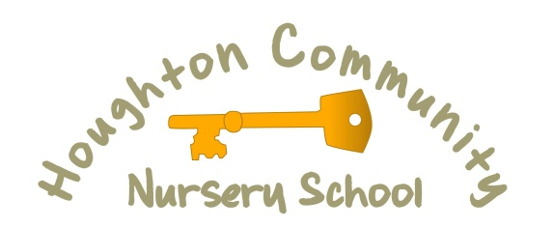
Mill Hill Nursery School

Job Description
Post Title | Early Years Practitioner
Salary | Grade 2 (point 5-6) - £19,312 to £19,698
Location | 3 Positions at Houghton Community Nursery and 3 Positions at Mill Hill Nursery School
Service Area | Education
Hours | Full time, 37 hours per week. All Year Round (AYR) Starting January 2022
Reports to | Head Teacher and Governing Body

Purpose of the Post:
- To be a key worker for a group of children, building relationships with the children and their families, ensuring they feel welcome and valued.
- To work alongside the wider team to plan and organise an environment in which the children have access to provocations and resources that they can explore and develop a love of learning from.
- To share the learning journey that children travel on by following their lines of enquiry and carrying out research together. This will be achieved by recognising children's wonders and questions of inquiry and then scaffold children's thinking skills around these concepts.
- To observe, record and document, reflect, revisit with the children, their families and the wider team to showcase children’s achievements.
Duties:
- To work as part of a team to develop an emergent curriculum which is child centred, follows the children’s interests and ignites new sparks and desires for learning and self discovery.
- To use their knowledge of child development alongside a range of documents including Birth to 5 Matters, the new EYFS, Development Matters, to ensure all children regardless of age and starting point make progress and reach their full potential.
- To work alongside the wider team to ensure high standards within the learning environment including display work and resources that reflect the children’s interests are maintained, cleaned and safe within the school.
- Ensure that all children gain a sense of belonging within a safe and nurtured environment where they feel confident to develop positive relationships both with adults and children within school.
- All children, their parents/carers, families, practitioners and surrounding communities are invited to work together to ensure that all children thrive, and develop a positive sense of belonging.
- To observe, record and document through the use of learning stories and analysis in planning books the learning and development of the children you work with.
- To support, promote and facilitate inclusion for all children by encouraging participation in all activities and by following and working towards targets identified in children’s individual plans.
- To liaise with the room lead, teachers, SENDCo and other agencies to support the implementation of an effective target based curriculum for children who require increased levels of intervention to meet their educational needs.
- To communicate effectively and sensitively with pupils to adapt to their needs and support their learning.
- To administer medication and other relevant care procedures to children in line with the child’s care plans and to record accurately any necessary information.
- In line with school policy and procedure, consistently apply positive behaviour management strategies.
- To prepare breakfast, snacks, tea and assist children with eating if needed whist encouraging independence.
- To ensure the children’s needs are met with regarding personal and intimate care, including changing clothes and nappies.
General
- Through a positive attitude, values and behaviours develop and sustain effective relationships with the whole school team
- To be aware of and comply with the schools policies for safeguarding and understand how to implement them in order to safeguard and promote the welfare of children and young people.
- To follow the Health and Safety Policies and procedures and ensure that reasonable care is taken at all times for the health, safety and welfare of yourself, the children and wider team.
- To contribute to the overall work, smooth running and pedagogy/values of the school by being flexible and adaptable.
- Confidentiality – All employees are required to undertake that they will not divulge to anyone personal and/or confidential information to which they may have access to during the course of their work in their home life or to anyone not working with the child and their family.
- To attend and participate in meetings as and when required.
- To improve one’s own practice and knowledge through training, self evaluation, and reflection.
- To participate in the schools performance management process
- Accompany other school staff and children on visits, outings and out of school activities as required and take responsibility for a group of children. .
- To participate in research and evaluation projects.
- To carry out any other duties which fall within the broad spirit, scope and purpose of this job description.
The Job description reflects the main tasks to be carried out by the post holder and identifies a level of responsibility at which they will be required to work. In the interests of effective working the tasks may be reviewed from time to time to reflect changing circumstances. Such reviews and any consequential changes will be carried out in consultation with the post holder.
The post holder must carry out their duties with full regard to the Council’s Equal Opportunities Policy, Code of Conduct, Child Protection Policy and all other Council Policies. The post holder must also comply with the Council’s Health and Safety rules and regulations and with Health and Safety legislation.
October 2021

