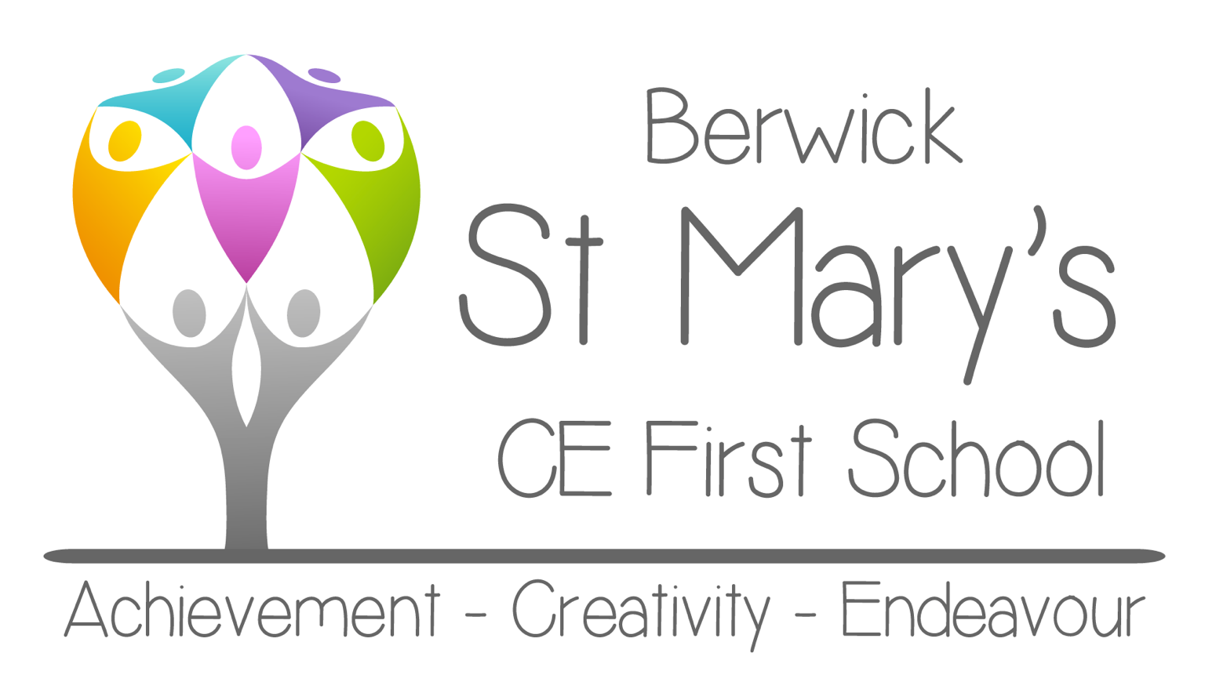

Recruitment Information Pack

Early Years/Nursery
Teaching Assistant

September 2020

Contents

Letter from Headteacher | 2
Application Process | 3
Vacancy Advert | 4
Job Description | 5
Person Specification | 7

Welcome from the Headteacher

Dear Applicant,

We are delighted that you are considering coming to join our team as our Early Years Teaching Assistant. We want the very best for all our children as we work towards becoming an outstanding school within our community. Since I joined the school, I have witnessed hard working, committed and friendly colleagues striving to improve all that we do for our children and their families. This is an exciting time in the life of our school as we go through a period of change which is opening up new opportunities for the whole school community.
We value the role of the Early Years Teaching Assistant and recognise the really positive impact it can have on the smooth and efficient running of the Early Years Unit. The importance we place on this role is reflected in the support, professional development and remuneration being offered.
We are a small first school on the border with Scotland with an increasing roll and reputation for providing inclusive and challenging educational provision. As a Church of England School we are proud of our recent Ofsted inspection which graded the school good, and acknowledged that ‘all children thrive’ within our setting. Our latest SIAMS inspection 2015, highlighted the importance we place on Christian core values in supporting our daily work in the developing the whole child.

We are committed to safeguarding and promoting the wellbeing of our children and all staff share this commitment. This post will be subject to an enhanced DBS Disclosure, suitable references and a pre-employment medical check.

This pack gives you all the information you need but we also encourage applicants to come for an informal visit.

We look forward to hearing from you.

Yours sincerely,

Gary Hilton
(Headteacher)

Application Process
Please return your completed application via e-mail to Admin@st-maryscofe.northumberland.sch.uk or by post to Mr Hilton, Headteacher, Berwick St Mary’s CE First School, Newfields, Berwick upon Tweed. TD15 1SP.
Queries
If you have any queries on any aspect of the application process or would like an informal discussion about the post please contact Mr Gary Hilton, Headteacher, on 01289 306170

The closing date for applications is 12 noon on Monday 21st September 2020.

Interviews will be held on Friday 25th September 2020

Vacancy Advert

Early Years/ Nursery Teaching Assistant

Position Start Date: A.S.A.P.
Employment Type: Fixed Term Contract to 31st August 2021, 27.5 hours per week, 39 weeks of the year.
Closing Date: 12 noon on Monday 21st September 2020
Date of Interview: Friday 25th September 2020
Pay Range: Band 2, Point 3: £18,065 – 18,426 FTE – 27.5 hours per week.

If you are ready for your next challenge, you will be delighted to hear about this Early Years Teaching Assistant post in a rapidly changing, forward thinking Church of England first school.
This role is designated to support children with additional needs, therefore experience of working in Early Years with children with additional needs is essential.
Due to the current circumstances we cannot allow visits to school, however, we would encourage anyone who is interested in the role to call the school for an informal discussion about the position. Please contact the school office on 01289 306170.
Berwick St Mary’s Church of England First School is committed to safeguarding pupils. There will be an enhanced DBS check prior to appointment.
The full job description and person specification are enclosed in this pack.

Berwick St Mary’s CE First School

Job Description

POST: Early Years/Nursery Teaching Assistant
RESPONSIBLE TO: The Head teacher, under the day-to-day management and leadership of Early Years Foundation Stage Lead.
KEY RELATIONSHIPS: Leadership Team; relevant teaching and support staff; partner professionals; parents and carers; local community; other Education and Healthcare professionals, School Governors.
WORKING PATTERN: 27.5 hours per week, term time only.
JOB PURPOSE: Teaching assistant to support children with additional needs within Early Years setting.
Duties

- To raise pupil achievement by developing outstanding EYFS practice in liaison with the EYFS team.
- Assist with the physical management and personal care needs for children in the Early Years Foundation Stage (including First Aid, where appropriate).
- Work with individual and groups of children to encourage them to achieve greater independence and self-confidence.
- Assess progress in accordance with EYFS policy and procedure and report to parents on a regular basis.
- Establish constructive relationships with parents and carers, promoting the Academy’s Home-School agreement.
- Establish rapport and respectful, trusting relationships with pupils, acting as a role model and setting high expectations.
- Supervise and provide particular support for pupils, including those with special needs, ensuring their access to learning resources.
- Promote inclusion and acceptance of all pupils in the classroom by encouraging them to interact with each other and to engage in activities led by the teacher.
- Support the implementation of IEPs, Behaviour Plans, personal care programmes, curriculum planning and assessment.
- To evaluate learning and provide feedback to the teacher / parent / agency as needed.

- Plan, deliver and evaluate differentiated learning activities.
- Promote good pupil behaviour, dealing promptly with conflicts in line with EYFS protocols and school behaviour policies.
- Contribute towards resourcing teaching, by developing and making resources as necessary for children in the class or year group.
- Attend to the health and hygiene needs of pupils as appropriate.
- Work with pupils on programmes linked to local and national curriculum and learning strategies e.g. literacy, numeracy, early years, recording achievement, progress and feeding back to colleagues and partners
- Monitor pupils’ responses to learning activities and achievement as directed.
- Provide detailed feedback on pupils’ achievement, progress, problems etc. as requested.
- Undertake pupil record keeping as required using Tapestry on-line assessment.
- Assist with the collation of pupil reports. This may involve data input.
- Support the effective use of IT in learning activities and develop pupils’ competence and independence in its use.
- Maintain a purposeful, orderly and supportive environment, in accordance with lesson plans. To clear away resources and materials after lessons.
- Display pupils’ work in the classroom and around school in accordance with academy policy.
- Prepare, maintain and use equipment/resources required to meet the lesson plans/learning activity and assist pupils in their use.
- Undertake routine administrative tasks e.g. photocopying, filing, collecting money, checking deliveries, placing goods in stock, and maintaining records of stock, reproducing work sheets for agreed activities.
- Be aware of and comply with policies relating to child protection, health & safety, confidentiality, safeguarding and data protection, reporting all concerns to a nominated person.
- Contribute to the overall work, smooth running and ethos of the Academy.
- Appreciate and support the role of other people in the team.
- Attend and participate in meetings as required.
- Improve one’s own practice through training, self-evaluation and performance management, including the School’s training days.
- Participate in the School’s Performance Management process.
- Accompany lead staff and pupils on visits, trips and out-of-school activities as required and take responsibility for a group under the supervision of a leader.

Berwick St Mary’s CE First School
Person Specification
Post Title: Early Years Teaching Assistant
 | Essential Criteria | How Assessed
Education & Qualifications | NVQ Level 3 in Early Years / Early Years practitioner qualification to at least a Level 3 standard  Excellent numeracy and literacy skills with GCSE English & Maths at grade C or above  Have undertaken training and have an excellent knowledge of the EYFS curriculum, assessment strategies, planning and intervention programmes and phonics  Willingness to undertake training in relevant learning strategies  Have experience of working in an early years setting and with 2 year olds | Application Form, Certificates & References
Experience, Skills and Knowledge | Working with or caring for children 0 to 5 years (Early Years)  Excellent understanding of a child’s development and learning  Commitment to and/ or experience of working with children with a range of Special Educational Needs (SEN).  Commitment to and/ or experience of ensuring access to the curriculum for children with SEN and whose first language is not English.  Understanding of the relevant policies/codes of practice/ and awareness of relevant legislation in the context of your role  Excellent understanding of national/ Early Years foundation stage curriculum and other relevant learning programmes/strategies.  Knowledge & experience of resources preparation to support learning programmes  Understanding of assessment strategies, planning and experience of occasional whole class cover supervision / unit leadership  Effective use of IT to support learning  Ability to write brief reports and keep records  Have excellent behaviour management skills  Excellent knowledge and understanding of safeguarding and health and safety  Excellent communication and organisational skills, ability to show initiative | Application Form, Interview & References
Personal Qualities | Ability to motivate and encourage children to meet their targets for learning and/or behaviour.  Ability to build effective relationships with pupils’ families, liaising sensitively & effectively with them, recognising your role in pupils’ learning.  To work constructively as part of a team, understanding classroom / unit roles and responsibilities and your own position within these.  To be an excellent role model.  Emotional resilience in working with a range of challenging situations.  Ability to demonstrate patience with firmness.  To constantly improve own practice/knowledge through reflection, self-evaluation and learning from others.  Have a willingness to demonstrate commitment to the values and behaviours, which flow from the Oasis ethos. | Application Form, Interview & References
Work Circumstances | To work flexibly as the workload demands  Occasional out of hours working to support school functions  This post is subject to Enhanced DBS, identity and qualification checks | Interview & References

