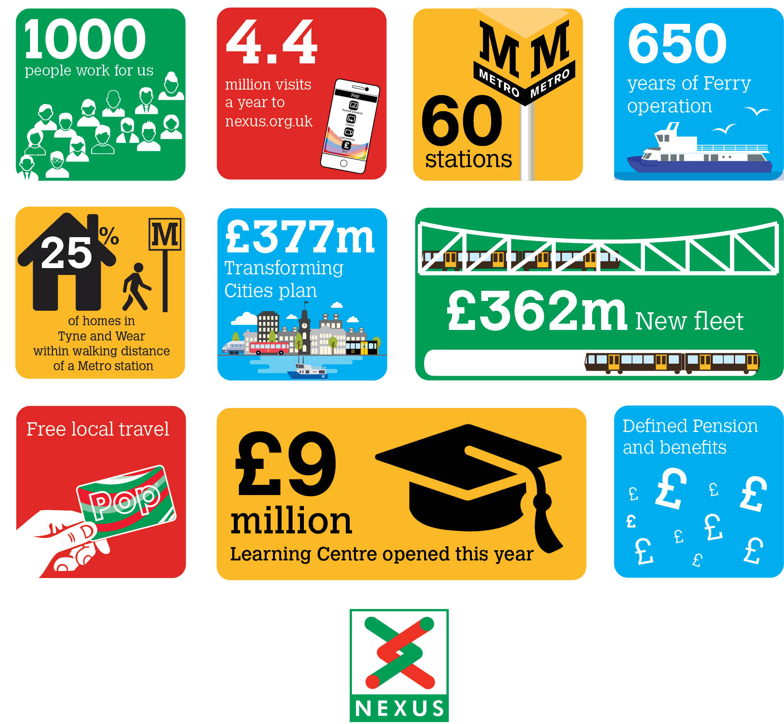
Be part of our story
Graduate Project Engineer (Major Projects)
18 Month Fixed Term Contract

Nexus are looking for four ambitious Engineering Graduates to work on an exciting multi-disciplinary rail project, through the design and construction phases.

Based in the Major Projects Directorate, the team are responsible for the delivery of portfolio of capital projects worth more than £400 million. We are seeking four talented Engineering Graduates, with a keen interest in Project Engineering, to be part of the team responsible for the delivery of the £104 million Metro Flow project.

An awareness of rail engineering and construction techniques, whether through learning or practical experience are essential to the role, as are good communication.

Salary: circa £28,000 pa
Plus, defined benefit pension scheme, free local travel and access to other benefits.
Closing date: 22 September 2021
Find out more at NorthEastJobs.org.uk

