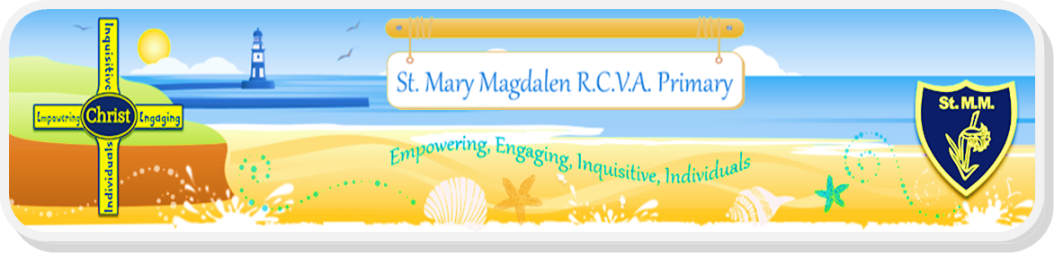

**Headteacher: Mr. L. Duncan** (MSc, BEng (Hons), PGCE)

Dene House Rd. Seaham. SR7 7BJ. Phone 0191 5813055

[www.st-marymagdalen’s.durham.sch.uk](http://www.st-marymagdalen's.durham.sch.uk)

Email:seahamstmary@durhamlearning.net

Dear Applicant,

**Post of Headteacher**

I have pleasure in enclosing a standard application form which I would ask you to complete and return to the Corporate Director, Children and Young People’s Services, Education Durham – Governance Services, County Hall, Durham, DH1 5UJ by email [EDGS.Administration@durham.gov.uk](mailto:EDGS.Administration@durham.gov.uk) by no later than **16 May 2021 at 11.59pm**.

Governors anticipate that a shortlist of candidates will be drawn up in **w/c 7 June 2021** to enable interviews for the post to take place on **18 June 2021**. It is anticipated that the successful candidate will take up duty on **1 September 2021**, or the soon as possible thereafter.

*Visits to the school are encouraged. Please contact the school office (contact number listed at the top of the letter) to make an appointment, with all visits to the school requiring to be undertaken by following the school Covid-19 Guidance Document and Risk Assessment.*

*For a discussion about the post, please contact Lawrence Kerrigan (Chair of Governors) at:* ***L.Kerrigan600@durhamlearning.net***

I have also enclosed the following information which I hope you will find helpful.

• Job description

• Person specification and criteria for selection

• Job advert

Further information about the school is available on our website.

I thank you for your interest in the post and wish you well should you decide to proceed with your application.

Yours faithfully

Mr L Kerrigan

Chair of Governors

[](https://www.google.co.uk/url?sa=i&rct=j&q=&esrc=s&source=images&cd=&cad=rja&uact=8&ved=0ahUKEwim5MvJ8uDXAhXBQBQKHdmGC44QjRwIBw&url=https://www.lomeshaye.lancsngfl.ac.uk/news/latest/2017-06-08-good-ofsted-rating&psig=AOvVaw34BIl35DmgLV_jPZf1quX6&ust=1511945629372711)  