The Duchess’s Community High School

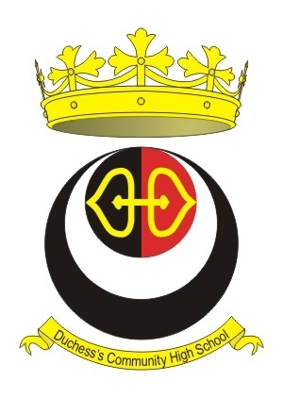
Taylor Drive, Alnwick, Northumberland NE66 2DH
Fax: 01665510602
Email: Admin@dchs-alnwick.org

“Building Relationships, Inspiring Success”

NOR 1450 (including 260 in the Sixth Form)

STUDENT SUPPORT & COMMUNITY LIAISON OFFICER

This is a permanent post and is for 35 hours per week, Term Time + 1 day
Hours are 8.30am – 4.00pm Monday – Friday

Salary: Band 3 £14,828 - £15,125 (being pro-rata of £18,795 – 19,171)

Further details of these posts and application forms are available on our website (www.dchs-alnwick.org) or by telephoning the school on 01665 602166.

The School is committed to safeguarding and protecting the welfare of children. The successful candidate will be subject to an enhanced DBS check.

Closing Date: 12.00 noon on Tuesday 21st January 2020

