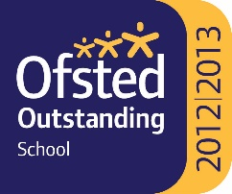

TEACHER OF MUSIC – Full / Part Time

Main / Upper Pay Scale
Required from January, 2022
NOR 1618, aGE rANGE: 11-18

As an experienced practitioner, you will be able to demonstrate your ability to engage with pupils and communicate a passion for Music. Your experience will enable you to teach this subject at key stages 3 and 4, and an ability to teach the subject at key stage 5 would be advantageous.

In return, you can be confident that you are joining a committed, supportive and very successful team. You will be coming to an extremely popular and over-subscribed 11-18 academy with over 1600 students, which …

- was judged “outstanding” in all categories in our Ofsted inspection in January, 2013
- in February 2009 featured in a national publication by Ofsted entitled ‘12 Outstanding Secondary Schools – Excelling Against the Odds’
- achieves excellent examination results in KS4 and KS5
- was designated as a ‘Teaching School’ in September, 2011
- opened a new 6th Form Centre in September 2010, offering an extensive range of level 3 courses, a varied enrichment programme and a challenging academic environment
- prepares all students for the destination of their choice, whether continuing in further and higher education or into the world of work

We are committed to safeguarding and promoting the welfare of children, young people and vulnerable adults. We expect all our staff and volunteers to share our commitment. Successful applicants are required to obtain an Enhanced Certificate of Disclosure from the Disclosure and Barring Service.

Application packs are available from Harton Academy’s website - https://harton-tc.co.uk/year-7-11/information/vacancies/teacher-of-music-part-time/ – and should be returned to Harton Academy by 12 noon on Tuesday 19th October, 2021.

Harton Academy is the Employer

