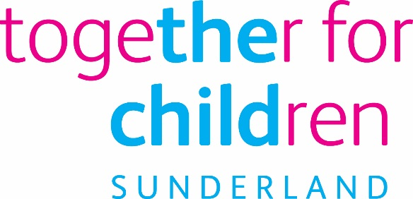
Job Description
Job Title: Business Admin Apprenticeship
Salary Grade: Apprentice rate
Job Family:
Job Profile:
Directorate: Early Help
Work Environment: agile
Reports to: TBC
Number of Reports: 0
Your normal place of work will be at various locations, but you may be required to work at any Company recognised workplace.

This position requires an Enhanced Disclosure and Barring Service (DBS) Check.

Purpose:
The Early Help Directorate within Together for Children are looking to take on a keen Business Administration Apprentice.

The successful applicant will provide administrative and technical support activities to a range of prevention and targeted youth services based within the Early Help Service to facilitate the efficient operation of the service.

Duties will include:

- Accessing, updating and organising bespoke information to maintain accurate and timely information for team members
- Prepare agendas for meetings, take notes in meetings, format reports and presentations so that accurate records are maintained and the information is available.
- Act as responsive and helpful point of resolution for enquiries and queries to the team
- Prioritising and appropriate dealing with or redirecting communications in a timely manner.
- Effectively maintain up to date office filing and personnel systems, stationary stock and equipment
- Support the smooth operation of the service
- Actively ensure the voice of the child is heard in design, delivery and evaluation of services within TFC and partner organisations
- Maintain own personal development to meet the changing demands of the job including undertaking appropriate training activities
- Actively participating in appraisals, objective setting and personal development plans

Training provider

NVQ Level 3 in Business Administration
Technical Certificate as applicable
Functional Skills where required
On the job training
Personal development
Apprenticeship framework
Business and Administration
Training provider

Applications for this apprenticeship are being processed by Together for Children

Safeguarding and Child Protection
- Follow Child Protection Procedures and liaise with the team around the child
- Develop professional, honest relationships with children, young people and families
Training
- Be a source of advice to colleagues and partners about the role of participation and engagement, their roles and responsibilities and support them to ensure the child’s voice is at the centre of everything they do

Key Responsibilities:
Essential Requirements

Qualifications:  3 GCSE grades A*-C including English and Maths, or equivalent are desirable. | Application Form Interview
Experience of:  - Word processing skill preferably Microsoft Word and other related software packages.  - Familiar with Spread sheets, preferably Excel.  - Ability to input data accurately.  - Demonstrate both the ability to be a team member and to work on own initiative.  - Speaking to people on the telephone  - Friendly, adaptable, helpful and enthusiastic.  - Good written and verbal skills.  - Understand the need to deal with customers sensitively.  - Understanding the need for confidentiality and secure data handling. | Application Form Interview
Knowledge and understanding of:  - The problems faced by children, young people and their families nationally, regionally and locally  - Being a young person in Sunderland who has accessed services from TfC | Application Form Interview
Ability to:  - Work within regulations and agreements pertaining to confidentiality, information-sharing, GDPR, safeguarding  - Engage in meaningful professional relationships with children, young people and their families  - Communicate effectively with a range of audiences and in a variety of formats (verbal and written)  - Work flexibly and on own initiative  - Make decisions and problem-solve  - Recognise and respond appropriately to risk  - Respond professionally to high levels of challenge  Offer support and guidance to team members when required  - Have the capacity to response to pressure and the demands of the working environment. | Application form Interview
Commitment to Equal opportunities | Interview

Statutory requirements:
In line with the Together for Children’s Statutory Requirements, all employees should:
Comply with the principles and requirements of the General Data Protection Regulation (GDPR) in relation to the management of Together for Children Sunderland’s records and information, and respect the privacy of personal information held by Together for Children Sunderland.
Comply with the principles and requirements of the Freedom in Information Act 2000;
Comply with the Together for Children Sunderland’s information security standards, and requirements for the management and handling of information;
Undertake the duties of the post in accordance with the Company’s Equal Opportunities Policy, Health and Safety Policy and legislative requirements and all other Company policies.
This position is a politically restricted post as identified by Together for Children and in accordance with The Local Government and Housing Act 1989 (LGHA).

Author: Jane Wheeler
Date: 01.02.2021

Author:
Date:

