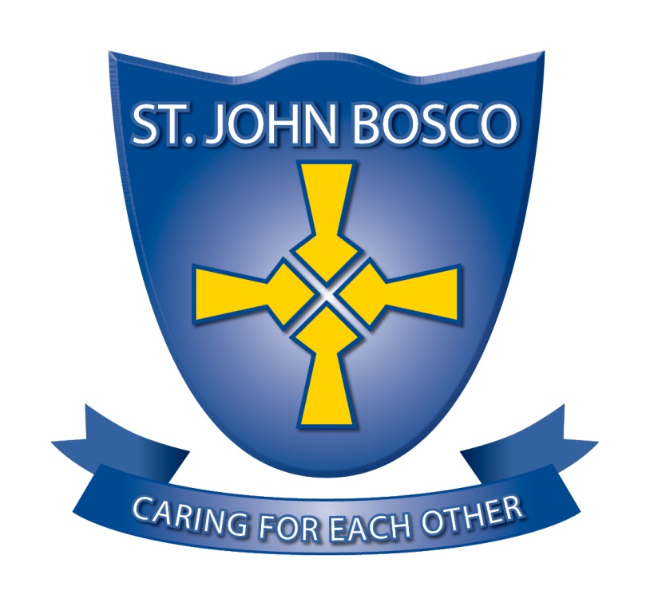

St. John Bosco RC Primary School

Person Specification
Class Teacher

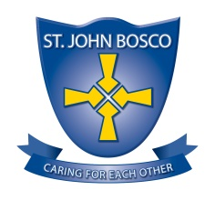

 | Essential | Desirable | Evidenced in
Qualifications and Training

Qualified Teacher Status | √ |  | Application
Commitment to Catholic Education and the distinct ethos of Catholic schools | √ |  | Application  Interview
Clear evidence of professional development |  | √ | Application  Interview
Safeguarding and Child Protection

Awareness of relevant policies and procedures relating to Child Protection | √ |  | Application  Interview
Awareness of relevant policies and procedures relating to Safeguarding Children | √ |  | Application  Interview
Personal Attributes

Demonstrates commitment, reliability and integrity | √ |  | Application  Interview
Communicates effectively with self-awareness and social perception | √ |  | Application  Interview
Has energy and resilience | √ |  | Application  Interview
Is willing to adapt to changing circumstances and new ideas | √ |  | Application  Interview
Commitment to equality | √ |  | Application  Interview
Demonstrates a caring and nurturing attitude | √ |  | Application  Interview
Professional Knowledge and Experience

Understanding of the role of a class teacher | √ |  | Application  Interview
Understanding of strategies to support successful outcomes for all children | √ |  | Application  Interview
Commitment to our pupils and their learning, wellbeing and safety | √ |  | Application  Interview
Ability to use initiative to respond to unexpected problems using recognised procedures and policies as a guide | √ |  | Application  Interview

 | Essential | Desirable | Evidenced in
Professional Skills

Ability to maintain a positive school ethos with an accent on high achievement and inclusion for all | √ |  | Application  Interview
Committed to meeting the needs of children whatever their ability or background | √ |  | Application  Interview
Able to work effectively with teaching assistants to ensure effective support for all children | √ |  | Application  Interview
Knowledge of assessment procedures and ability to relate them to curriculum planning. | √ |  | Application  Interview
Good organisation and planning skills | √ |  | Application  Interview
Ability to communicate and promote the aims and objectives of the school | √ |  | Application  Interview
A belief that primary education should be a lively, stimulating, enjoyable experience which achieves high standards | √ |  | Application  Interview
Committed to working with parents, colleagues and other agencies in a positive and constructive manner | √ |  | Application  Interview
Ability to motivate and stimulate pupils of all abilities to enjoy learning. | √ |  | Application  Interview
Ability to use Information Technology for assessment and analysis purposes |  | √ | Application  Interview
Ability to make appropriate judgements over issues of confidentiality and safeguarding. | √ |  | Application  Interview
An excellent understanding of a range of behaviour management strategies. | √ |  | Application  Interview
Professional Philosophy and Commitment

Ability to reflect and question self. | √ |  | Application  Interview
Prepared to be involved in the whole life of the school. | √ |  | Application  Interview
Understanding of and commitment to developing links between home, school, neighbouring schools and different communities | √ |  | Application  Interview
SAFEGUARDING
The Governing Body of St John Bosco RC Primary School are committed to safeguarding and promoting the wellbeing of children and young people and the Headteacher will ensure that the highest priority is given to following guidance and regulations to safeguard children and young people. You will need to demonstrate knowledge and understanding of relevant guidance and legislation, and to display commitment to the protection and safeguarding of children and young people. The successful candidate will be required to undergo an enhanced DBS check before securing their employment at St John Bosco RC Primary School

