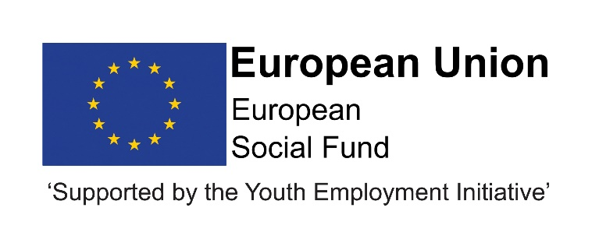
Job Description
Post title | Apprentice (DurhamWorks)
Grade | Apprentice
Service | Children and Young Peoples Service
Service Area | Education and Skills
Reporting to | Progression Team Managers
Location | Your normal place of work will be one of the following – Seaham Contact Centre, Stanley Education Centre or Civic Centre Crook but you may be required to work at any Council workplace within County Durham.
DBS | This post is subject to a enhanced disclosure.
Flexitime | This post is eligible for flexitime.
Politically restricted | This post is not designated as a politically restricted post in accordance with the requirements of Section 1(5) of the Local Government and Housing Act 1989 and by regulations made from time to time by the Secretary of State.

Description of role

The post holder will be accountable to the Progression Team Leader and will be supported and mentored to develop in the role by the team. The Apprentice will establish good working relationships with a range of internal and external colleagues and partners.

Duties and responsibilities

To learn and be given training in the required skills and responsibilities over the term of the apprenticeship to then be able to undertake the full range of duties listed below:
- To study and achieve the Business Administrator Level 3 during the duration of the apprenticeship
- Learn how to receive visitors and referring to appropriate colleagues
- Develop skills to answer telephones and record messages
- word processing, production of reports and preparation of presentation slides
- Learn how to update and maintain databases and filing systems and photocopying
- Be able to despatch and receive/open post and other material and ensuring prompt despatch to appropriate staff
- Ensuring appropriate support for, and the health and safety of, visitors
- Develop the skills to use multiple IT packages and systems relevant to the organisation in order to write letters or emails.
- Learn how to produce accurate records and documents including emails, letters, reports & proposals and make recommendations for improvements and present solutions to management
- Understand the importance of decision making and learn how to make effective decisions based on sound reasoning and deal with challenges in a mature way
- Develop interpersonal skills to be able to build and maintain positive relationships within your own team and across the organisation.
- Learn how to influence and challenge appropriately and become a role model to peers and team members, developing coaching skills as you gain area knowledge
- Develop good communications skills, whether face-to-face, on the telephone, in writing or on a digital platform and use the most appropriate channels to communicate effectively
- Demonstrate the necessary level of expertise required to complete tasks and apply yourself to continuously improve your work.
- Learn how to take responsibility for initiating and completing tasks, managing priorities and time in order to successfully meet deadlines
- Develop skills to use relevant project management principles and tools to scope, plan, monitor and report.
- Ensure appropriate attention is given to your own health and safety, and the safety of your colleagues and visitors, following established procedures.
- Work within current Data Protection requirements, Information Sharing protocols and guidelines.
- To attend training as determined appropriate by the Council in relation to working practices and the Apprenticeship programme.

Organisational responsibilities

- Values and behaviours
To demonstrate and be a role model for the council’s values and behaviours to promote and encourage positive behaviours, enhancing the quality and integrity of the services we provide.

- Smarter working, transformation and design principles
To seek new and innovative ideas to work smarter, irrespective of job role, and to be creative, innovative and empowered. Understand the operational impact of transformational change and service design principles to support new ways of working and to meet customer needs.

- Communication
To communicate effectively with our customers, managers, peers and partners and to work collaboratively to provide the best possible public service. Communication between teams, services and partner organisations is imperative in providing the best possible service to our public.

- Health, Safety and Wellbeing
To take responsibility for health, safety and wellbeing in accordance with the council’s Health and Safety policy and procedures.

- Equality and diversity
To promote a society that gives everyone an equal chance to learn, work and live, free from discrimination and prejudice and ensure our commitment is put into practice. All employees are responsible for eliminating unfair and unlawful discrimination in everything that they do.

- Confidentiality
To work in a way that does not divulge personal and/or confidential information and follow the council’s policies and procedures in relation to data protection and security of information.

- Climate Change
To contribute to our corporate responsibility in relation to climate change by considering and limiting the carbon impact of activities during the course of your work, wherever possible.

- Performance management
To promote a culture whereby performance management is ingrained and the highest of standards and performance are achieved by all. Contribute to the council’s Performance and Development Review processes to ensure continuous learning and improvement and to increase organisational performance.

- Quality assurance (for applicable posts)
To set, monitor and evaluate standards at individual, team and service level so that the highest standards of service are delivered and maintained. Use data, where appropriate, to enhance the quality of service provision and support decision making processes.

- Management and leadership (for applicable posts)
To provide vision and leadership to inspire and empower all employees so they can reach their full potential and contribute to the council’s values and behaviours. Managers and leaders must engage in personal development to ensure they are equipped to lead transformational change; always searching for better ways to do things differently to meet organisational changes and service priorities.

- Financial management (for applicable posts)
To manage a designated budget, ensuring that the service achieves value for money in all circumstances through the monitoring of expenditure and the early identification of any financial irregularity.

The above is not exhaustive and the post holder will be expected to undertake any duties which may reasonably fall within the level of responsibility and the competence of the post as directed by your manager.

Person specification
 | Essential | Desirable
Qualifications | - Either have or expect to achieve 4 GCSE’s at Grades A-C/9-4 or hold an equivalent and relevant qualification  - Ability to achieve Level 3 Business Administrator during the duration of the apprenticeship  . | - IT qualification  - Administrative qualification
Experience | - Use of Microsoft Office applications | - Experience of dealing with people and/or young people.  - Office administration  - Providing Reception and Clerical support to a range of staff  - Customer Service
Skills & Knowledge | - Ability to follow instructions  - Ability to work in a team  - Ability to work on own initiative  - Good communication skills  - Good IT skills  . | - Knowledge of computer systems  - Health & Safety awareness  - Data protection awareness  - Awareness of the Councils role
Personal Qualities | - Behave in a professional way  - Respect and encourage diversity  - Punctuality  - Positive attitude  - Reliability  - Self Motivation | - Feel confident in dealing with queries

