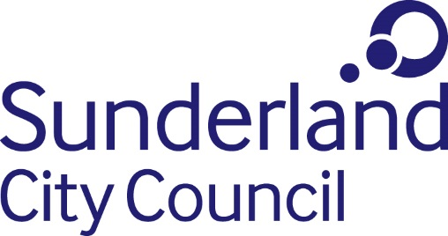

Job Description

Job title: Human Resources & Development Assistant
Directorate: Corporate Services
Grade: Grade 4 / Grade 6 (Career Progression Scheme)
Responsible to: Senior HRD Business Partner

Purpose of Role

- To provide advice and guidance to managers on employment related matters, HR policies and procedures and terms and conditions of employment.

2. To build and develop effective working relationships at all levels of the organisations and to provide business focused HRD support and guidance.

Key Tasks and Responsibilities of Role

3. To support the interpretation and application of the Council’s HR policies and procedures, terms and conditions, and employment law.

4. To take a proactive role in advising on reducing absence within the Council to help achieve the organisation’s targets.

5. To assist and advise line managers on disciplinary and grievance matters, recruitment and selection, performance management, organisational change, workforce planning and employee development.

6. Support investigations, preparation of cases for hearings and participation in meetings, which are of a sensitive and confidential nature.

7. To attend first level formal meetings as appropriate, providing appropriate advice and support to line managers.

8. To provide support in the management of poor performance, misconduct and sickness absence issues in accordance with the Council’s policies and procedures.

9. To support with organisational change, including administrative processes behind staff consultations, avoidance of redundancy situations and TUPE transfers.

10. Provide written and verbal responses to ad hoc queries from managers and employees.

11. To provide support to disciplinary, grievance and other such processes including setting up, and taking and typing of notes of meetings and hearings.

12. Ensure HR policies and procedures are reviewed and updated, reflecting both current good practice as well as legislative requirements, and the needs of the Council.

13. To develop and maintain effective working relationships with trade unions, in accordance with the Council’s framework, and to participate in formal negotiations with trade union officers where required.

14. Ensure HR knowledge is up to date, including legislation, best practice and trends in HR.

- Co-ordinate, develop and provide appropriate training in respect of employment related issues.

- To provide operational support to the Senior / HR Business Partner in managing the workforce implications of restructuring/redundancy/TUPE exercises.

17. Any other duties as required.

Additional Information/Other Requirements

18. Carry out duties with full regard to the Council’s Equalities policies, Code of Conduct and all other Council policies.

- Comply with the Council’s Health and safety policy, rules, regulations and Health and safety legislation.

- Comply with the principles and requirements of the General Data Protection Regulation and the Data protection Act 2018 in relation to the management of Council records and information, and respect the privacy of personal information held by the Council; comply with the principles and requirements of the Freedom in Information Act 2000; comply with the Council's information security standards, and requirements for the management and handling of information; and use Council information only for authorised purposes.

- The post holder will be required on occasion to travel within the City/region as appropriate to undertake the role.

Date: April 2021

