Job Title: Overhead Linesperson

Purpose: To carry out maintenance and renewal of the overhead line equipment and associated power
supply systems to meet the needs and requirements of the section.
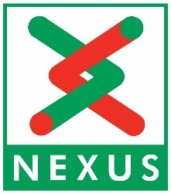

EDUCATION | E/D
SPECIFIC KNOWLEDGE
Be authorised for carrying out switching duties in the railway or electricity utilities sector. | D
Be Senior Authorised to be able to issue safety documentation in the railway or electrical utilities sector, or a commitment to work towards it. | D
Experience in or a commitment to work towards WSC / Train master, Lookout. | D
SKILLS
Current UK Driving Licence | E
Class C (LGV) licence and CPC or a commitment to work towards one. | D
Have basic IT skills | E
Have basic literacy and numeracy skills. | E
Heavy Plant Operator. | D
EXPERIENCE

Have demonstrable experience, in power supplies and overhead line maintenance. | D
Have demonstrable experience, in power supplies and overhead line renewals. | D

E Essential Criteria
D Desirable Criteria

