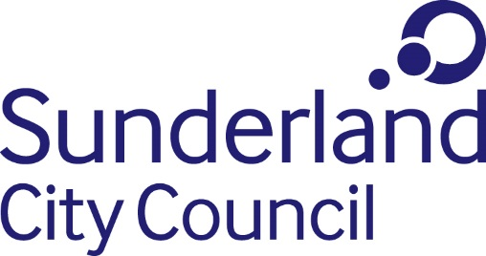
Person Specification

Job title: Graphic Design Executive / Senior Executive
Directorate: People, Communications and Partnerships
Grade: Grade 2 / Grade 4 (Salary in accordance with experience)
Responsible to: Graphic Design Officer

Essential Requirements | Method of Assessment
Experience/Education/Training  - Some experience of delivering graphic design within a communications setting, ideally in an agency or large organisation.  - A commitment to continued professional development. | Application Form/ Interview
Skills/Knowledge and Ability  - Be able to communicate effectively verbally, in person or over the telephone, and in writing to share and obtain information.  - Listens to others to assess requirements to respond appropriately and efficiently.  - Ability to deploy organisational brands across marketing publications and materials.  - Strong interpersonal skills including the ability to work with colleagues and senior leaders.  - Able to work effectively within a busy team environment, or independently.  - Ability to prioritise tasks and deliver to sometimes tight timescales with minimum supervision.  - Ability to deliver graphic design in terms of digital content, for example basic animation, or a willingness to undertake training to do so.  - Able to see tasks through to completion, ensuring they are completed on time or to deadlines and to a high degree of accuracy. | Application Form/ Interview
Work related circumstances  - Able to work outside of usual office hours when required around key events.  - Compliance with health and safety rules, regulations and legislation.  - Commitment to Equal opportunities.  To promote the Council’s values. | Application Form/ Interview

