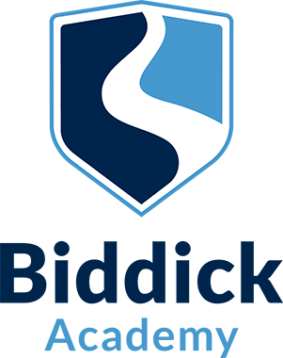

Application Pack
HLTA – Early Intervention

Start Date – 1 September 2021
Closing Date: 21 June 2021 at 9am

Dear Applicant
Thank you for your interest in the post of HTLA – Early Intervention at Biddick Academy.
Our aim is to inspire children to learn, unlock their potential and achieve success. We are passionate and determined that every student feels a sense of achievement, enjoys their learning, is happy and cared for, and develops as a well-rounded individual.
At Biddick Academy, we are preparing students not just to excel in examinations but also to have the skills and attributes to be successful in life. Our curriculum is designed with the intention of developing curious, resilient, aspirational young people who leave us, truly ready for their next steps. We recognise the importance of the informal and formal curriculum and actively encourage a wealth of extra-curricular activities.
I am proud to lead a team of exceptional staff who develop positive relationships with students and are committed to providing opportunities so that students fulfil their potential. You will be joining a team that works together, supporting and motivating each other to ensure our students thrive and flourish.
Biddick Academy is at the heart of the local community and for this reason; the Academy is a warm, energetic and supportive environment. We provide a comprehensive induction programme for new colleagues and offer a range of high-quality professional development opportunities.
I would like to wish you the best of luck with your application and should you require any further information please do not hesitate to contact the Academy.

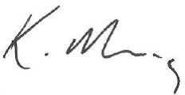
Miss K. Morris
Headteacher

Academy Information
As an oversubscribed school, Biddick Academy has an excellent reputation in the local community. With 1100 students on roll and a specialist ASD provision compromising of 35 places, Biddick Academy is a dynamic place to work. We have 6 feeder primary schools and our catchment area is comprehensive, encompassing a wide variety of backgrounds.
The Academy has benefited from significant investment over a number of years and has excellent facilities, including a purpose-built Engineering workshop and Hair and Beauty salon. After school hours, the Academy is busy with many community groups using the 3G pitches and leisure facilities.
As an organisation, we want everyone, students and staff alike, to:

- Be part of a safe and respectful community
- Feel happy, valued and empowered so that we all thrive
- Aspire to be the best we can be
- Act with integrity
- Nurture resilience and independence
- Have the attitude and character to excel in life
- Have a desire to learn and work with passion, purpose and pride

Curriculum
Key Stage Three
In Years 7 to 9 students study a broad range of subjects that, at the end of Key Stage Three, enable them to make informed choices for their GCSEs. For example, at present students study the following subjects: English, Mathematics, Science, Geography, History, Religious Education, Physical Education, Music, Art, Design Technology, ICT, IAG (Information, Advice and Guidance), Accelerated Reader, Spanish/French.

Key Stage Four
At the end of Year 9, students make choices regarding the courses they would like to study in Years 10 and 11. All students study GCSEs in the following subjects: English Language, English Literature, Mathematics, Science, History and /or Geography. In addition, all students must also continue to study Physical Education, Ethics, and IAG (Information, Advice, Guidance) as part of the non-examined curriculum.
Students may then choose from a wide variety of further subjects to make up their option choices. At present GCSEs and vocational courses are available in: French, Spanish, Philopshy and Ethics, Engineering, Computer Science, Creative iMedia, Business and Enterprise, Food and Nutrition, Fine Art, Art and Design, Textiles, Digital Art, Hair and Beauty, Physical Education, Dance, Drama and Music.

Student Support Team
We are expanding our Student Support Team which work proactively with small groups of students, members of staff, families and carers to overcome behavioural barriers to learning.
The post holder will help to develop and implement a curriculum which meets the needs of our young people, ensuring behaviour standards are met and that students focus on academic progress. One purpose of the role will be to ensure that our pupils are able to reintegrate successfully back into mainstream education with a renewed motivation and positive attitude to learning.

