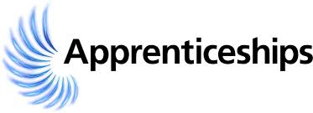
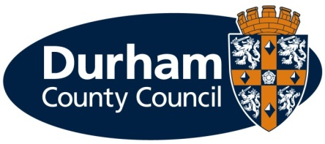
Durham County Council

Apprenticeship Information Pack
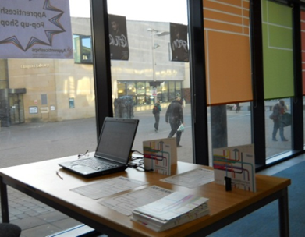

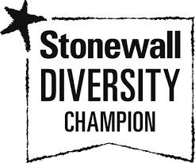
What is an apprenticeship?

Apprenticeships are an excellent option for all ages. An apprenticeship is an exciting job opportunity where you will receive formal training to gain a recognised qualification alongside gaining technical knowledge, practical experience and wider skills you need for employment and a future career.

What types of apprenticeships are available?

Durham County Council provides services to all parts of the county to meet the needs of our residents and help everyone in County Durham. The services we provide are wide ranging. The council offers a variety of job opportunities and apprenticeships are also available in areas including accounting, gardening/horticulture, civil engineering and business administration to name a few. We may have the career to meet your aspirations.

The apprenticeships on offer here today are all part of our Business Services function, a team who support administration and business services activities across all areas of the Council.

Successful candidates will be based in teams across the Council, learning, developing and supporting our teams. As part of that you will work toward a L3 Diploma NVQ which is fully funded and done during working hours (assignment work is approximately 1 day a week).

Further information on the council’s services can be found on our website at www.durham.gov.uk

We are pleased to be offering the following apprenticeships for a November 2021 start. Further information on the job role can be found in the job description. Click on the links in the table below to find out more about the formal training you will be undertaking during the apprenticeship:
Service | Apprenticeship | Duration | Location | Training | Training provider
Directorate of Resources  Procurement, Sales and Business Services  Business Services | Business Services Administration Apprentice  11 teams | 2 years | See advert for list of teams and locations | Business Administrator Level 3  and  Diploma L3 | Adult Learning & Skills Services
What are the different levels of apprenticeship?

There are a range of apprenticeships at different levels including:

- Intermediate level apprenticeship (Level 2) – equivalent to five GCSE passes
- Advanced level apprenticeship (Level 3) – equivalent to two A level passes

How much will I earn?

This will depend on the type of apprenticeship you are doing.

If you are working towards a Level 2, 3 or 4 qualification during the term of your apprenticeship (excluding craft apprenticeships) you will be paid:

- £4.30 per hour for the first year of your apprenticeship

- If you are aged 19 years or over and have completed the first year of your apprenticeship you will then be paid:

  - 19 to 20 year old £6.56 per hour
  - 21 to 22 year old £8.36 per hour
  - 23+ years £8.91 per hour
(Rates effective from 1 April 2021)

You will be paid on the last working day of each month, with the money paid directly into your bank account.

Your apprenticeship training will be fully funded by the council.

What should I expect from an apprenticeship at the council?

- A workplace induction to help you understand your role and the council;
- A structured work programme working alongside experienced employees;
- Ability to study towards a recognised qualification;
- Regular review meetings with your manager;
- A workplace mentor;
- Opportunities to undertake work based and off the job training;
- Access to a range of training opportunities;
- Support to help you apply for jobs;
- To be part of an Apprenticeship Network where you will receive updates of what is happening across the council including any training or job opportunities available, build a network of support, be able to discuss support/information required and put forward ideas for improvements;
- Working in an environment that promotes an inclusive and diverse workforce.

What are the additional benefits of working for the council?

- Holiday entitlement;
- Local Government Pension Scheme (LGPS);
- A range of flexible working options, some depending on job role;
- Maternity, adoption, paternity, compassionate and bereavement leave;
- Occupational sickness pay;
- Health and wellbeing including Occupational Health, physiotherapy and Employee Assistance Programme;
- Discounted access to membership for the council’s leisure facilities;
- Car Leasing Salary Sacrifice Scheme;
- Cycle to Work Scheme;
- Travel Loan Scheme;
- Opportunity to buy additional annual leave;
- Discounts on a range of products and services.

How do I apply?

If you are not already registered you will need to register with the North East Recruitment Portal and apply online at https://www.northeastjobs.org.uk/default.aspx?page=orghome&orgid=73

Click on the apprenticeship job category to see the opportunities available.

Hints and tips for a successful application:

Be yourself

- What is it about you that will make your application stand out? Make sure to include relevant skills, knowledge and experience.

Do your research

- Ensure that you are familiar with Durham County Council, it’s values and the services it delivers. Having a sound knowledge of the role played by the council and the information from the job description will help make your application stand out and allows you to discover what it is that really interests you about becoming an apprentice with the council.

Include examples from your work experience, outside interests and/or volunteering

- We are interested to know what you are involved in and motivated by. Try and use a range of examples from your work experience and any extra-curricular activities to demonstrate how you are the best person for the role. If you have little or no previous work experience don’t be put off, tell us what you understand about the role and give examples from your personal life experience and interests.

Make it easy to get yourself shortlisted

- Structure your application in a logical way around the criteria asked for in the person specification. Remember you will need to demonstrate to us how you meet the criteria asked for in the person specification. Don’t just say ‘I can do that’, tell us how you have demonstrated it through work, experience, outside interests or volunteering.

- Remember to check your spelling and grammar!

Key dates:

Closing date | see advert
Shortlisting | - the week after above closing date
Interviews | - the week after the shortlisting above

If you are shortlisted you will receive notification of the date and time of your interview via an e-mail from the North East Recruitment Portal.

If you require any reasonable adjustments at the application or selection stage, please contact Peter Brockman, Senior Resources and Development Officer (Organisational Workforce Development Team) on Tel: 03000 268 547 or via email peter.brockman@durham.gov.uk

The impact of coronavirus means that the recruitment process for apprenticeship posts will be a little different this year, with interviews, enrolment, and induction carried out on-line, but all applicants will be supported throughout the whole process.

What will happen if I am offered an apprenticeship?

You will be required to have some pre-employment checks e.g. references, qualification certificates and we will also need confirmation from the training provider that you meet the requirements to undertake the training element of the apprenticeship before your employment is confirmed.

Additional support

As a disability confident leader, we welcome applications from people with disabilities and as an inclusive employer we recognise the importance and benefits of having an inclusive and diverse workforce. To ensure we can offer the best possible support for applicants, we will pro-actively make reasonable adjustments within the recruitment and selection process for disabled people.

The range of reasonable adjustments that can be accommodated throughout the selection process include (but is not exhaustive):

- Alternative formats for job applications;
- More detailed/pictorial instructions for interview;
- Support from an appropriate person at the interview;
- Additional time to complete applications (and or tests) where appropriate;
- Adjustments to interview venue/accommodation;
- Adjustments to method of testing;
- Adjustments to interview questions e.g. receiving questions in advance.

Please contact Peter Brockman, Senior Resources and Development Officer, Organisational Workforce Development Team on Tel: 03000 268 547 or via email: peter.brockman@durham.gov.uk to discuss any reasonable adjustments in more detail. This will ensure you get the appropriate support during the recruitment and selection process.

In addition to reasonable adjustments, the council also provides a ‘guaranteed interview scheme’ which allows people with disabilities to be shortlisted where they demonstrate they can meet the essential criteria of the role.

What happens if I am unsuccessful?

If you have been unsuccessful with your application to a role at Durham County Council, we would like to support you as much as possible with reviewing your options. Therefore:

- If you are between 16-24 years of age, live in County Durham and would like help with any future apprenticeship applications, tailored one to one advice, careers guidance and support with your options and access to potential funding and job vacancies please find out more about DurhamWorks at https://durhamworks.info/ send us an e-mail at: durhamworks@durham.gov.uk or telephone: 0300 026 2930.

- If you are 19 years of age and older you can also access support, information, advice and guidance or access accredited qualifications on a formal or flexible basis through the council’s Adult Learning and Skills Service (ALSS). For more information or to speak to one of our engagement team, please contact us by emailing alss@durham.gov.uk or telephone: 03000 266 115

There are no restrictions, in terms of accessing these services, and we would treat each enquiry on an individual basis.

We look forward to hearing from you.

COVID-19 update
We are carrying out risk assessments of our premises and work-related activities during the COVID-19 pandemic in accordance with Government and Public Health England guidance to ensure our existing staff and new recruits can all work safely. Constant reviews will be undertaken to ensure compliance with current guidance. Overarching risk assessments for our workplaces and our activities and people can be viewed via the following link

Core values and behaviours

Our values describe how we work and the organisation we want to be, by demonstrating the core behaviours we embed each of the four values in our work to provide the best possible service to our communities and create a great place to work.

