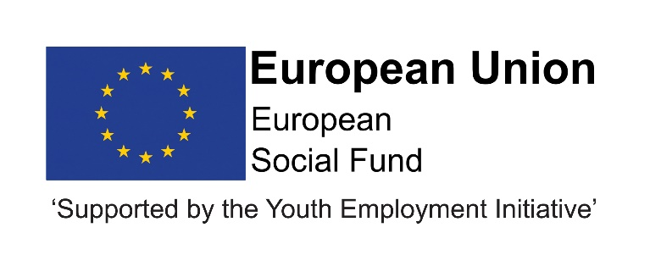

JOB DESCRIPTION

Children and Young People’s Services

POST TITLE: Resource Assistant

POST NUMBER:

GRADE: 5

Job Evaluation Ref No: N10440.

LOCATION: Your normal base will be at the Civic Centre, Crook. However
you will be required to work at any council workplace within County Durham; in a range of schools, colleges and independent private providers; and across the North East region and beyond.

5. RELEVANT TO THIS POST:
This post is funded through ESF and the Youth Employment Initiative (YEI) as part of the 2014-2020 European Structural and Investment Funds Growth Programme in England. The YEI/ESF funding will end in July 2021.

Flexible Working: Subject to service needs the Council’s flexible working policy is applicable to this post.

6. ORGANISATIONAL RELATIONSHIPS
The post holder will be responsible to the Resource Coordinator. The post holder will be required to establish positive working relationships with colleagues within the Progression and Learning team, and with a wide range of suppliers to the programme.

7. DESCRIPTION OF ROLE
The post holder will undertake financial and administration duties relating to the purchasing and claims processing for the programme, including the DurhamWorks Flexible Fund payments.

DUTIES AND RESPONSIBILITIES SPECIFIC TO THIS POST

- Support responses to requests for advice and information from managers and staff with respect to the administration of expenditure for the DurhamWorks claim.

- Support the implementation of systems and administration processes for the ordering of goods and equipment together with payment of invoices for the DurhamWorks claim, in accordance with County Council’s Financial Systems and Standing Orders.
- Ensure ordering of goods, receipting and payment of invoices are within timescales and in accordance with procedures to ensure continuity of the programme.

- Maintain and store confidential information relating to the programme and ensure the archiving and or destruction criteria is applied when appropriate.

- Ensure that financial records are processed, recorded and monitored.

- Check all expenditure information provided is eligible and all paperwork is complete in line with the DurhamWorks guidance.

- Collate claim information and support the timely completion of the monthly DurhamWorks claim

The above is not exhaustive and the post holder will be expected to undertake any duties which may reasonably fall within the level of responsibility and the competence of the post as required by the Service.

COMMON DUTIES AND RESPONSIBILITIES

Quality Assurance

To set, monitor and evaluate standards at individual, team performance and service quality so that the user and the Service’s requirements are met and that the highest standards are maintained.

Professional Practice

To ensure that professional practice in the team is carried out to the highest standards and developed in line with the Service’s stated objectives of continual improvement in quality of its service to internal and external customers.

Health and Safety

To ensure that the Health and Safety policy, organisation arrangements and procedures as they related to areas, activities and personnel under your control are understood, implemented and monitored.

General Management

To provide vision and leadership to staff within the potholder's team, ensuring that effective systems are in place for workload allocation and management, the application of the Authority’s and the Service’s policies and procedures, including those relating to equality, supervision and appraisal and all aspects of their performance, personal development, health and welfare.

Financial Management

To manage a designated budget (as required) ensuring that the Service achieves value for money in all circumstances through the monitoring and control of expenditure and the early identification of any financial irregularity.

Appraisal

All members of staff will receive appraisals and it is the responsibility of each member of staff to following guidance on the appraisal process.

Equality and Diversity

As an organisation we are committed to promoting a just society that gives everyone an equal chance to learn, work and live free from discrimination and prejudice. To ensure our commitment is put into practice we are developing policies, which will seek to remove any barriers to equality of opportunity and to eliminate unfair and unlawful discrimination.

These policies apply to all employees of Durham County Council.

Confidentiality

All members of staff are required to undertake that they will not divulge to anyone personal and/or confidential information to which they may have access during the course of their work.

Induction

The Council has in place an induction programme designed to help new employees to become effective in their roles and to find their way in the organisation.

PERSON SPECIFICATION: Grade 5 – Resource Assistant

 | Essential | Desirable | Method of Assessment
Qualification | BTEC National, NVQ Business Administration Level 3 or equivalent |  | - Application  - Selection process  - Pre-employment checks.
Experience | - Experience of financial administration systems  - Experience of establishing/maintaining monitoring and record-keeping of systems. | - Experience of Local Government or other public sector financial systems  - Experience of preparing European grant claims or claims for similar grant-funding regimes. | - Application  - Selection process  - Pre-employment checks.
Skills/Knowledge | - Good at dealing with numerical information  - Ability to work effectively in a team, but also capable of individual initiative  - Excellent ICT skills including the use of Microsoft Office. |  | - Application  - Selection process  - Pre-employment checks.
Personal Qualities | - Ability to work effectively in a team  - Ability to carry out work with the minimum of supervision  - Able to relate well and quickly to other team members and people from other organisations  - Open to change and committed to innovative development  - Ability to work under pressure and to deadlines  - Holds high aspirations for young people/young adults. | - Innovative and prepared to see things through.  - Prepared to learn new skills. | - Application  - Selection process  - Pre-employment checks.

