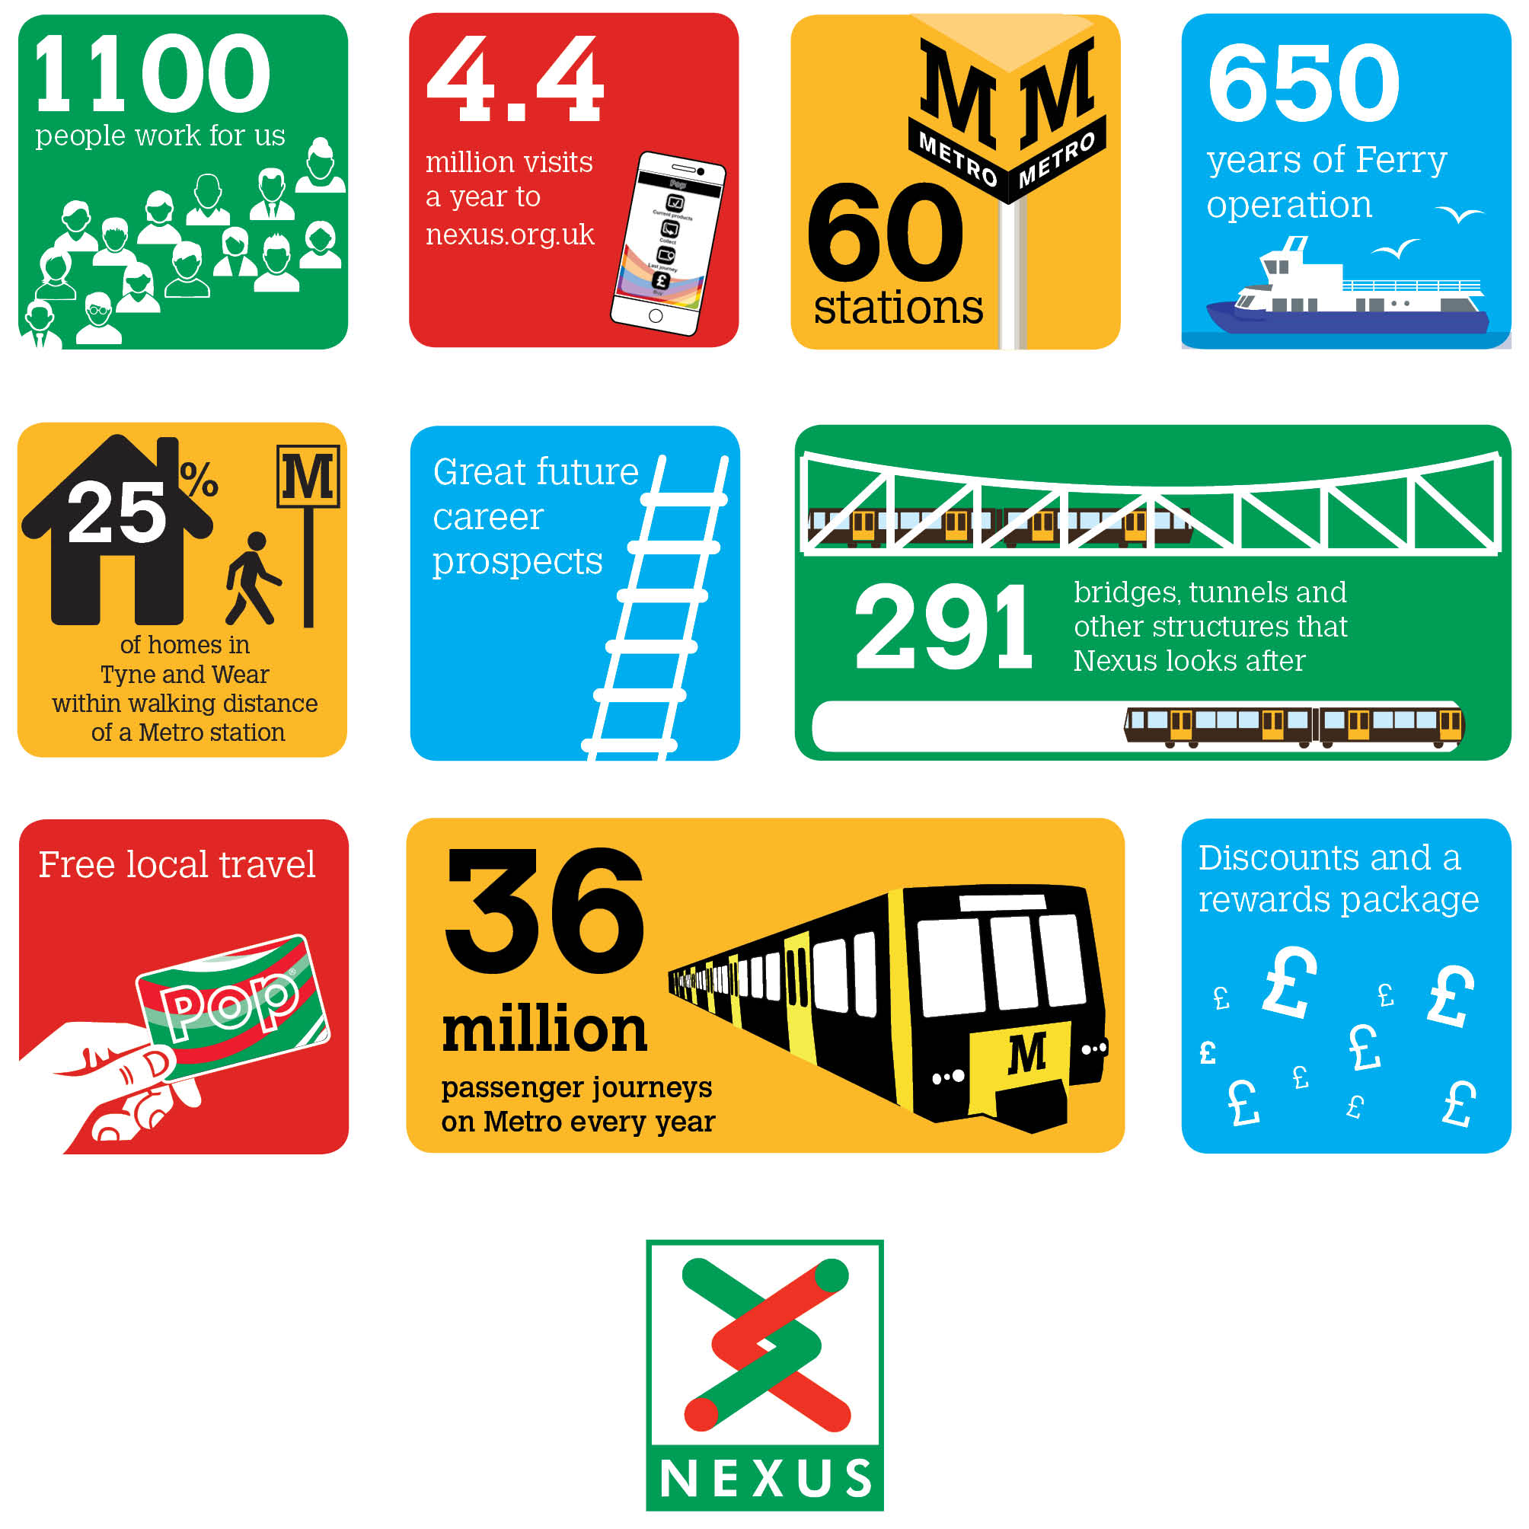

Be part of our story
Assistant Contracts Manager
We are currently seeking to recruit an Assistant Contracts Manager to work at the Metro Control Centre in South Gosforth. The Assistant Contracts Manager is a new role in the Commercial department and is responsible for the management of the new fleet maintenance contracts which will commence in late 2020.
This role will play an important part in the successful introduction of the new fleet of Metro trains and related maintenance. The successful candidate will provide advice and support across Nexus to ensure effective management of contracts.
Salary Band 4 £26,456 to £39,688
Plus defined benefit pension scheme, free local travel and access to other benefits.
Closing date 28th October 2020
Find out more at recruitmentmetro@nexus.org.uk

