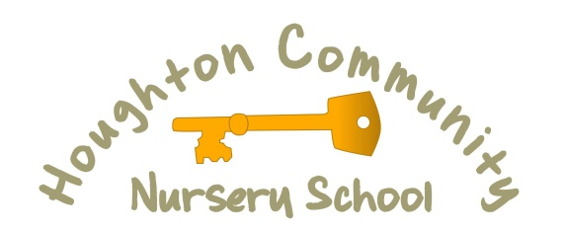
Mill Hill Nursery School

Person Specification
Post Title | Early Years Practitioner
Salary | Grade 2 (point 5-6) - £19,312 to £19,698
Service Area | Education
Selection Method: A = Application / I = Interview
ATTRIBUTES | ESSENTIAL CRITERIA | METHOD FOR TESTING | DESIRABLE CRITERIA | METHOD FOR TESTING
Qualifications and Training | Relevant and validated Early Years Qualification at Level 3 or above  Maths and English Qualification Level 2 or above.  Evidence of on-going commitment to own professional development and learning | A  A  A | Paediatric First Aid | A
Experience, Skills, Knowledge | Excellent Early Years practitioner with commitment to and understanding of what high quality Early Years practice involves.  Knowledge of the revised EYFS and KCSIE 2021  Good level of understanding of how young children learn and develop.  Experience of using assessment information to support learning and progress.  Recent experience of working within the EYFS.  Current experience of planning and evaluating learning  Key Worker experience with the ability to observe, and recording learning.  Experience of liaising with and building effective working partnerships with parents/carers and the wider family.  Excellent subject knowledge, with understanding of strategies for meeting the needs of all children, which inspire motivate and challenge.  A sound knowledge and understanding of safeguarding children, including high expectations for pupil behaviour.  Good level of understanding of the importance of the learning environment and an ability to provide an exciting, attractive and stimulating space for children.  Ability to build, sustain and develop effective working relationships with staff, governors, parents and the wider community.  Ability to contribute to meetings and liaise with other agencies.  Ability to establish professional relationships and to take an active role within a team  Understand the need for confidentiality, and be able to implement confidentiality protocol  Able to deal sensitively with adults and children | A/I  A/I  A/I  A/I  A/I  A/I  A/I  A/I  A/I  A/I  A/I  A/I  A/I  A/I  A/I  A/I
Personal Attributes and Aptitude | Good communication and inter-personal skills (written and spoken)  Good level of organisation and be able to plan and manage workload.  Ability to use ICT effectively both in classroom practice and within own professional work.  Willingness and desire to commit to the ethos and wider life of the school.  Enthusiasm and ability to use own initiative and resolve problems as they arise  To be highly motivated and enthusiastic and be approachable, reliable, and conscientious.  Maintain professional standards at all times, whilst promoting our caring and supportive ethos to the children and their families.  To be flexible, open-minded, self evaluative and adaptable to changing circumstances and new ideas.  Be able to use own initiative  Show warmth and a sense of humour  Ability to demonstrate a stimulating and innovative approach.  Commitment to continuing personal and professional development by attending training | A/I  A/I  A/I  A/I  A/I  A/I  A/I  A/I  A/I  A/I  A/I  A/I
Equal Opportunities | Ability to demonstrate awareness and understanding of equal opportunities and of other people’s behaviour, physical, social and welfare needs.  Ability to create and maintain a working environment which values the individual, challenges discrimination and respects confidentiality | A/I  A/I
Health and Safety | Ability to demonstrate a clear understanding of and commitment to Health and Safety and a willingness to undertake training to enable implementation of procedures.  Be able to apply Health and Safety effectively with children and the wider staff team | A/I  A/I

