On-call Firefighter Application information pack

Contents
Introduction 3
Our area 4
About us 5
Could you be an on-call firefighter? 6
Job description 7
Rates of pay 9
Pre-application information 100
Do you really want to be an on-call firefighter? 133
On-call firefighter recruitment process 144
Stage 1 – Online assessment 155
Stage 2 - Role related tests 166
Stage 3 – Interview 19
Stage 4 – Fitness test 19
Stage 5 – Medical 20
Stage 6 – References and Baseline check 200

Introduction
County Durham and Darlington Fire and Rescue Service (CDDFRS) is pleased to invite applications for on-call firefighters to join us in this challenging and highly rewarding career. Our communities’ value the services we offer and need to feel confident in the highly skilled teams we have, reducing risk as well as dealing with emergency situations. We are continually evolving and improving how we operate, whilst maintaining the highest standards.
If you feel that you have what it takes, we invite you to join our recruitment process.
This document has been written to provide you with details of each stage of the recruitment process for the role of on-call firefighter. It is important that you are aware of how you will be assessed and what to expect at each stage. All details that you need to apply are provided in this document.
If you have any queries prior to the recruitment process please email Humanresources@ddfire.gov.uk

Our area
CDDFRS provides a fire and rescue service from 15 strategically placed fire stations managed via two divisions, north and south. The fire stations are staffed by either wholetime firefighters, part-time ('on-call' previously termed retained) firefighters or a combination of both.
Placing our operational, community and fire safety staff in local areas enables us to provide a more integrated, cohesive and focused approach to addressing local risks, as well as improving access to services and advice for local residents and members of our business community.
The map below shows where the stations are located throughout the service area.
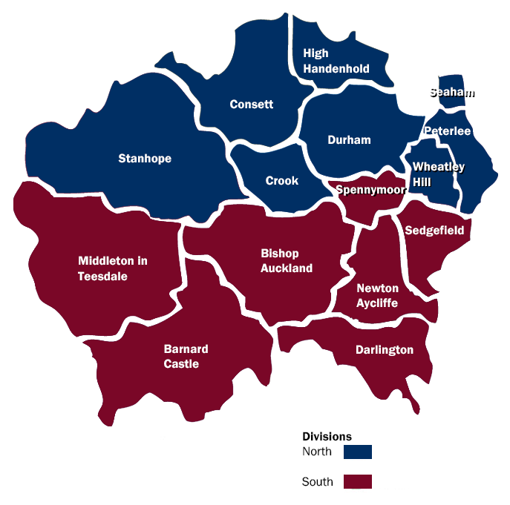
Thirteen of our stations provide on-call cover.

About us
CDDFRS are here to make the communities within our area a safer place to live, work and visit. We are governed by a separate statutory body known as the Combined Fire Authority. Our Service is accountable to the Combined Fire Authority which is comprised of locally elected councillors who are members of the authority.
County Durham and Darlington Fire Authority is responsible for the fire and rescue service across the two unitary authority areas of County Durham and the borough of Darlington, serving a population of over 620,000 people spread over almost 2,460 square kilometres.
Fire cover is provided 24-hours a day, every day of the year.
All 999 calls are received by our control room at Service Headquarters at Belmont. Fire engines are then mobilised from 15 fire stations across the Service area. All front-line fire engines are equipped with state-of-the-art rescue equipment and there is also a fleet of specialist appliances, which are used during road traffic collisions, water rescues and other specialist rescues. Firefighters are trained and ready to respond to a range of emergencies, not just fire. These include road, rail or air crashes, flood, animal rescues, chemical spills and even terrorist attack.

Could you be an on-call firefighter?
You need to be over 18, live or work within five minutes of an on-call station and can respond at a moment’s notice. Instead of being based at a fire station, you are called out to respond to incidents when alerted. On-call firefighters come from every walk of life and no previous experience is required due to the comprehensive training program you will undertake.
All on-call firefighters attend a drill night every week to take part in training exercises and carry out equipment maintenance. Many on call firefighters also spend time working in their local communities to help reduce the risk of fires and incidents by attending local events and performing safe and wellbeing checks.
Our on-call firefighters commit to between a minimum of 40 hours per week on-call, up to a maximum of 120 hours per week. You won’t spend all this time working - it’s just the time you’re available for us to call you if there’s an incident. You can choose when you want to provide cover daytime, evening, weekends, or a combination of the three, provided this fit in with the station requirements.
Although it sounds like a big commitment many people successfully balance their on-call firefighter duties with another job. Some are self-employed whilst others have permission from their employer to leave work for short periods during the daytime if necessary.
Firefighting is not like any other job. It can be unpredictable, exciting and rewarding, coupled with the satisfaction and respect that comes with providing a crucial service to your local community. You will learn new skills along the way such as first aid, road traffic collision procedures and fire safety.

Job description

Role:
Firefighter

Location:
Your local on-call fire station.

Duties and responsibilities:

Emergencies
- Respond immediately and safely to all emergency calls and requests for assistance.
- Deal with emergencies as directed and work effectively and efficiently as a member of a disciplined team.
- Minimise distress and suffering, including giving first aid care.

Dealing with people
- Establish and maintain the confidence of members of the public.
- Maintain links within the community.
- Be sensitive to the needs of others with regard to fairness and dignity issues.

Fire safety
- Give general fire safety advice and guidance to people when requested.
- Work to help educate members of the community in the risks and hazards of fire and other emergencies.
- Assist in Service initiatives, programmes, and strategies to reduce fire calls.

Health and safety
- Recognise health and safety issues at work and deal with them to minimise or eliminate the degree of hazard or risk.
- Ensure personal safety and that of others at all times.

Personal fitness and hygiene
- Maintain level of physical and medical fitness necessary to carry out the duties of a Firefighter.
- Maintain personal appearance, hygiene, and cleanliness of uniform in keeping with a disciplined service.

Equipment
- Maintain all firefighting and emergency equipment in a state of readiness, including cleaning, repairing, and testing as required to approved standards and procedures.
- Check firefighting resources provided for Fire and Rescue Service use, including hydrants and fixed installations.

Local geography
- Know the local streets, roads and buildings situated within the fire station response area.
- Be aware of the risks, possible hazards, and water supplies to be found within the fire Station area.

Administration
- Complete basic paperwork and routine administration, including recording of information.
- Use information technology as required and in accordance with the Data Protection Act 1998.
- Keep personal records up to date.

Training
- Take part in a continuous training programme by attending lectures, exercises, practice drill sessions and other forms of training to maintain competence levels.
- Attend training courses as directed.

Fire authority
- Undertake any other duties commensurate with the level of responsibility and expertise as may be required by the Chief Fire Officer.
- Adhere to the policies and procedures of the Service.

Rates of pay
As an on-call firefighter you receive an annual retaining payment, plus hourly rates and disturbance fees (paid when attending incidents).
Rates of pay for on-call firefighters from 1st July 2017.
Firefighter | Full annual retainer (based on 120 hours availability i.e. 100%) | Hourly rate | Disturbance payment per call out
Trainee Development Competent | £2383  £2483  £3177 | £10.88  £11.34  £14.51 | £4.18  £4.18  £4.18

The retaining fee is worked out based upon the number of hours availability given by the employee on a weekly basis and employees are paid for exactly what they have worked. This is paid bi-annually.
On-call firefighters are paid an hourly rate of pay for attending the following:
- Drill Night
- Turnout
- Training Course
- Community safety
- Standard tests

Pre-application information

Age
Applicants must be 18 years of age or over at the commencement of training. Your date of birth is verified as part of the process.

Work permit
As an employer, the Fire Authority is subject to the provisions of the Asylum and Immigration Act 1996. It could be guilty of committing a criminal offence if it employed someone who does not have permission to be in or to work in the United Kingdom. The Fire Authority reserves the right therefore to request relevant documentation from all those offered employment to satisfy its obligations in this respect. For more information, you may find the following immigration advice website useful: www.workpermit.com or www.ukba.homeoffice.gov.uk.

Identification
As an employer, we need to ensure all prospective employees have the right to work in the United Kingdom. You will be asked to bring some form of photographic identification e.g. passport, driving license, any other relevant documentation and a work permit if applicable with you at the interview stage of the recruitment process so your identification can be verified. Please visit www.ukba.homeoffice.gov.uk for more information on prevention of illegal working.

Driving
If you hold a driving licence you must inform us if your licence is endorsed, giving details to the nature of the offence, offence code (e.g. CD10 driving without due care and attention) and give details of the penalty (e.g. £ fine and number of penalty points). If you have had to attend court you need to give details of the outcome.

Diversity monitoring
This helps us ensure we are as accessible as possible to all groups in the community. The data is held in accordance with the Data Protection Act and is not used to assist or make selection decisions. It will be used for statistical analysis only.

Medical standards
Fire and Rescue Authorities are required to assess each applicant on an individual basis with regard to their suitability to perform the role of a fire-fighter, in accordance with Equality Act legislation. This means that Fire and Rescue Authorities will consider what reasonable adjustments could be made to enable you to proceed with your application provided any such adjustments do not contravene Health and Safety legislation. Health & Safety legislation places the obligation on Fire and Rescue Authorities to ensure that individuals are safe at work for their own protection and that of others. (In the context of the Fire and Rescue Service "others" includes colleagues and members of the public).
To ensure that support is readily available, you are required to bring your specific needs to the attention of the human resources team in advance. Please email Humanresources@ddfire.gov.uk
The visual entry standards for fire-fighters are as detailed below:
- Unaided visual acuity of 6/60 and read N48 at least 30cm with both eyes open.
- Have a corrected visual acuity of at least 6/9 and read N12 at 30cm with both eyes open. Please note, applicants can use glasses of an appropriate specification on the fire ground should they be needed to obtain this standard of vision.
- Have normal binocular visual field determined by confrontation techniques or formal testing methods.
- Operational firefighters must have an appropriate level of colour perception. Individuals with either normal colour vision or slightly abnormal green colour vision are suitable for appointment.
If you are unsure whether you meet these requirements you are advised to seek advice from a qualified optometrist.
Candidates who have undergone laser eye surgery will not be considered for an appointment to a position for a minimum of 12 months after the date of the procedure. This does not preclude anyone from joining the recruitment process.

Declaration of offences
You are required to declare any offence for which the conviction is not yet spent. Within the meaning of the Rehabilitation of Offenders Act 1974 – incorporating the Rehabilitations of Offenders Act (exemptions) 1975 and the Rehabilitation of Offenders Act 1974 (exemptions) (Amendment) Order 1996 – you are advised to declare any charge that is pending as a subsequent conviction could lead to your dismissal from the Service.
Broadly the Act provides for anyone who has ever been convicted of a criminal offence and not sentenced to more than 2.5 years in prison to become a ‘rehabilitated person’ at the end of the rehabilitation period, provided there have been no further convictions. At the end of this period, the conviction is considered spent and thus to be treated as it had never happened. There are fixed rehabilitation periods for specific offences. If you are unsure whether you must declare a previous conviction you should contact your local Probation Office, Citizens Advice Bureau, or your Solicitor. Alternatively, you can consult the Home Office publication ‘A Guide to the Rehabilitation of Offenders Act 1974’.

Do you really want to be an on-call firefighter?
The following list of questions has been designed to help you decide whether being an on-call firefighter is really for you. Simply tick Yes or No to each of the following questions.
 | Yes | No
Are you genuinely interested in people?
Can you get on with people from different backgrounds and cultures?
Do you want to work as part of a close-knit team?
Can you work under pressure?
Can you think on your feet and solve problems when you know a lot depends on the suggestion you come up with?
Do you have the sensitivity to deal with members of the public when they are distressed, confused or being obstructive?
Can you take responsibility for representing the Service when you are at work and when you are not?
Are you committed to always maintaining and developing your skills?
Are you committed to maintaining your health and physical fitness?
Are you prepared to work in situations where you may see blood, seriously injured or dead people?
Are you prepared to talk to people in the local community about fire safety?
Are you a practical person who likes to work with your hands/equipment?
Do you enjoy making things or finding out how things work?
Are you someone who can always be relied on to be somewhere on time?
Are you prepared to work at height?
Are you prepared to work outside in all types of weather, when it is wet and cold?
Are you prepared to work unsociable hours?
Are you prepared to work in enclosed spaces?
Are you prepared to carry heavy equipment?
Do you live within 5 minutes of an on-call fire station
If you answered ‘Yes’ to ALL of the above, and you think that you have what it takes to serve and protect the community you live and work in, read the information provided and join our recruitment campaign.

On-call firefighter recruitment process
The following notes are designed to give you an indication of the recruitment process what to expect and what will be required of you. There are 6 stages:
- Online assessment
- Role related tests
- Interview
- Fitness test
- Medical
- References and Baseline check
Feedback will be available following completion of the process.

Stage 1 – Online assessment
The initial stage of the recruitment process is undertaken online, there is no application form to complete and return. Please note that CVs or any other form of application will not be accepted.

Dyslexia
If you are dyslexic and require reasonable adjustments you must contact the human resources team on 0191 3755583 or email Humanresources@ddfire.gov.uk who will advise you of how to continue with your application. Evidence of your dyslexia will be required.
The online assessment is divided into four elements, each must be completed before progressing to the next stage.

Sift
Requires you to register and provide some personal details. You will only be able to apply once.
Once you have registered you will have the opportunity to complete a realistic job preview questionnaire which will give you more information about being a firefighter and help you understand some of the challenges and demands of the role. This is not assessed but will help you determine whether the role is for you before you move on to the formal tests.
You will also be asked some basic questions to ensure that you are eligible to apply. As part of your eligibility assessment, we will identify for example: -
- Whether you are over the age of 17 years and 6 months
- Whether you have the right to work in the UK
- Whether you have any unspent convictions that may temporarily preclude you from working as a firefighter (all unspent and pending convictions must be declared – failure to do so will result in your application being automatically withdrawn)
If you meet the eligibility requirements you will be invited to complete the next element of the process.

Behavioural styles questionnaire
Explores your preferred behaviours and values in a working environment. The purpose of the questionnaire is to assess whether you have the right behaviours and attitudes to be effective in the role. No revision or additional study is required for this element and the test is untimed.

Situational judgement test
Measures your judgement and decision-making skills in situations that are typical in the Fire and Rescue Service. No knowledge or experience as a firefighter is required to complete this test and no prior revision is needed. The test is untimed.

Ability tests
There are 3 ability tests:
- Numerical reasoning – Candidates will be required to calculate basic numerical equations that are equivalent to GCSE level maths.
- Verbal reasoning – Candidates will be required to answer questions on short passages of information. No prior knowledge is required.
- Mechanical reasoning – Candidates will be required to apply cognitive reasoning to mechanical, physical, and practical concepts in order to solve problems.
The ability tests are timed, with a specific amount of time allocated per question.
If you are successful you will receive an email inviting you to the next stage of the process.

Stage 2 - Role related tests
If you are successful at the online stage you will be invited to undertake the role related or practical tests which will be held at our training centre in Bowburn. The role of a firefighter is physically demanding so it is important for us to assess your ability to handle the situations and challenges you will face. The tests are designed to assess your level of physical fitness in line with the requirements of the role. Candidates must perform all the tests whilst wearing firefighter personal protective equipment (PPE), provided on the day. For each test, full instructions will be provided.
Ladder climb – designed to assess confidence at heights. Wearing a safety harness, you are required ascend two thirds of the way up a 13.5 metre ladder and take a leg-lock. You will be asked to lean backwards and outstretch your arms to the sides, then confirm a symbol being shown by the assessor at ground level.
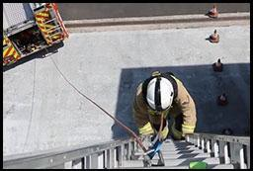

Casualty evacuation – designed to assess upper and lower body strength and coordination
Candidates drag a 55kg dummy backwards around a 30M course, by a carrying handle fixed to the dummy.
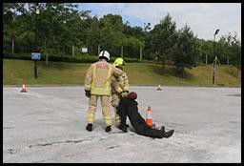

Ladder lift – designed to assess upper and lower body strength and coordination
Candidates raise the bar of a ladder lift simulator to the required height with 15kg of weight placed on the simulator cradle, which gives a total lift load of 24kg.
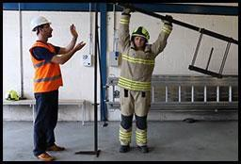
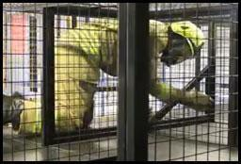
Enclosed space – designed to assess confidence, agility, and stamina. Candidates put on a facemask and with un-obscured vision make their way through a crawl and walkway. Once inside the crawl/walkway they have their vision obscured and return to the start.

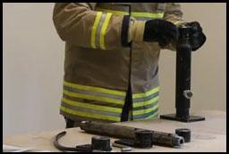
Equipment assembly – designed to assess manual dexterity. Candidates are given a demonstration of the test before having to assemble and disassemble a number of components to make an item of equipment.

Equipment carry –designed to assess upper and lower body strength and coordination
Candidates carry items of equipment up and down a course between two cones placed 25m apart. They are given a brief, a demonstration of correct lifting techniques and are permitted to practice picking up the correct items.
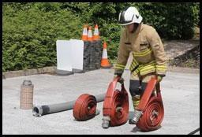

Stage 3 – Interview
Upon successfully passing the practical tests you will be invited to attend an interview and presentation which will last for about an hour. This will be our chance to get to know more about you and ask you more about the information you provided with your online application.

Stage 4 – Fitness test
Firefighting can be a physically demanding and hazardous activity with potential for exposure to high physiological and environmental loads. To ensure effective and safe operational performance an appropriate level of physical fitness is essential.
Should you be successful at interview stage, you will be invited to attend a fitness assessment (VO2 max) which will be carried out on a treadmill to determine aerobic fitness. The minimum requirement for candidates at recruitment is 42.3 mls/O2/kg/min (equivalent to level 8 shuttle 8 on a bleep test).

Stage 5 – Medical
We will need you to take a full medical assessment prior to joining us which will be conducted by our occupational health provider. You will complete a questionnaire looking at your medical history and complete the following tests:
- Hearing test
- Lung function
- Eye test
- Grip strength
- Blood pressure
- General tests based on your completed medical questionnaire
- Drug and alcohol test
It is important that you do not complete any exercise or consume alcohol or caffeine immediately prior to the medical.

Stage 6 – References and Baseline check
If you are successful at all stages of the recruitment process we will need to check your references. Should an unsatisfactory reference be received, any offer of employment will be withdrawn.
We will also need to carry out a standard Baseline personal security standard check (BPSS). Once we have both references and a satisfactory BPSS check is received back we will be in a position to offer you a post as an on-call firefighter.
Offers of employment will be made as vacancies arise and your details may be placed on a holding list.
We would like to take the opportunity to wish you every success throughout the recruitment process.
If you have any queries, you are invited to email:
Humanresources@ddfire.gov.uk

