FIRE CONTROL APPRENTICESHIP

CANDIDATE INFORMATION

Contents

Introduction
Our area
About us
Could you be a fire control operator apprentice?
Apprenticeship programme and job role information
Pre-application information
Do you really want to be a fire control operator apprentice?
Recruitment process
Stage 1 – Application form
Stage 2 – Ability and practical tests
Stage 3 – Interview and presentation
Stage 4 – Medical
Stage 5 – References and baseline check

Introduction
County Durham and Darlington Fire and Rescue Service (CDDFRS) is pleased to invite applications for apprentice fire control operators to join us in this challenging and highly rewarding career. Our communities’ value the services we offer and need to feel confident in the highly skilled teams we have in handling emergency calls. We are continually improving how we operate, whilst maintaining the highest standards.

If you feel that you have what it takes, we invite you to join our recruitment process.

This document has been written to provide you with details of each stage of the recruitment process. It is important that you are aware of how you will be assessed and what to expect at each stage.

All details that you need to apply are provided in this document.

If you have any queries prior to the recruitment process, please email:
ldarling@ddfire.gov.uk

Our area
CDDFRS provides a fire and rescue service from 15 strategically placed fire stations managed via two divisions, north and south. The fire stations are staffed by either wholetime firefighters, part-time ('on-call' previously termed retained) firefighters or a combination of both.

Placing our operational, community and fire safety staff in local areas enables us to provide a more integrated, cohesive, and focused approach to addressing local risks, as well as improving access to services and advice for local residents and members of our business community.

The map below shows where the stations are located throughout the service area.

Thirteen of our stations provide on-call cover.

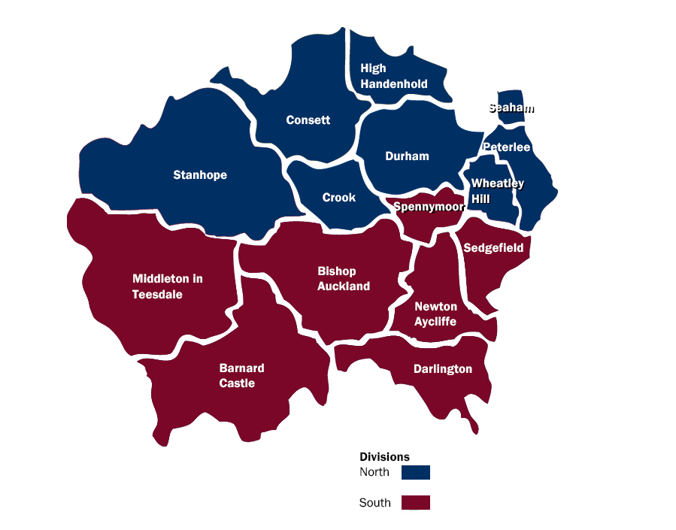

About us

CDDFRS are here to make the communities within our area a safer place to live, work and visit. We are governed by a separate statutory body known as the Combined Fire Authority. Our Service is accountable to the Combined Fire Authority which is comprised of locally elected councillors who are members of the authority.

County Durham and Darlington Fire Authority is responsible for the fire and rescue service across the two unitary authority areas of County Durham and the borough of Darlington, serving a population of over 620,000 people spread over almost 2,460 square kilometres.

Fire cover is provided 24-hours a day, every day of the year.

All 999 calls are received by our fire control room at Service Headquarters at Belmont. Fire appliances are then mobilised from 15 fire stations across the Service area. All front-line fire appliances are equipped with state-of-the-art rescue equipment and there is also a fleet of specialist appliances, which are used during road traffic collisions, water rescues and other specialist rescues. Firefighters are trained and ready to respond to a range of emergencies, not just fire. These include road, rail or air crashes, flood, animal rescues, chemical spills and even terrorist attack. Fire control operators are trained to deal with the handling and mobilising to the range of emergencies we attend.

Could you be an apprentice fire control operator?

You must be aged 18 or over at the time of appointment.

The programme has a tailored and structured design covering apprenticeship standard Emergency Contact Handling Level 3 and Firefighter (Control) National Occupational Standards.

The Command and Control Centre is responsible for handling all emergency calls, determining correct resources, mobilising, and responding to requests for assistance from operational crews. In addition, it is responsible for maintaining operational cover to ensure fire appliances are always strategically deployed in response to our service standards.

Fire Control Operators in the Command and Control Centre handle almost 15,000 emergency 999 calls per year: ensuring that crews, officers, fire engines and equipment are dispatched to where they're needed.
Fire Control Operators need to be effective, confident communicators, remaining calm under pressure. These skills are particularly important when trying to extract vital information from often very distraught callers, about the severity of incidents and more importantly their location within County Durham and Darlington, then communicating this information to firefighters.
Fire Control Operators stay on the phone, assessing the risks posed to the caller and giving fire survival advice in what can be very stressful, life-threatening situations.
They also perform a vital role, communicating between crews attending incidents and other emergency services and authorities who need to attend - such as the Environment Agency, if for example, chemicals are involved that can pose a threat to people, property or the environment.
They are encouraged to identify possible malicious false alarm calls. These are not just a nuisance; they can be life-threatening because crews attending these false alarms will be unavailable should a genuine incident occur at the same time.

Pre-application information

Age
Applicants must be 18 years of age or over at the commencement of the programme. Your date of birth is verified as part of the process.

Work permit

As an employer, the Fire Authority is subject to the provisions of the Asylum and Immigration Act 1996. It could be guilty of committing a criminal offence if it employed someone who does not have permission to be in or to work in the United Kingdom. The Fire Authority reserves the right therefore to request relevant documentation from all those offered employment to satisfy its obligations in this respect. For more information, you may find the following immigration advice website useful: www.workpermit.com or www.ukba.homeoffice.gov.uk.

Identification

As an employer, we need to ensure all prospective employees have the right to work in the United Kingdom. You will be asked to bring some form of photographic identification e.g., passport, driving license, any other relevant documentation, and a work permit if applicable with you at the interview stage of the recruitment process so your identification can be verified. Please visit www.ukba.homeoffice.gov.uk for more information on prevention of illegal working.

Driving

If you hold a driving licence you must inform us if your licence is endorsed, giving details to the nature of the offence, offence code (e.g., CD10 driving without due care and attention) and give details of the penalty (e.g., £ fine and number of penalty points). If you have had to attend court, you need to give details of the outcome.

Diversity monitoring

This helps us ensure we are as accessible as possible to all groups in the community. The data is held in accordance with the General Data Protection Regulations (GDPR) and is not used to assist or make selection decisions. It will be used for statistical analysis only. You can find out about your rights and how we will protect your data in our “Universal Privacy Notice” which can be found on our website.

Declaration of offences

You are required to declare any offence for which the conviction is not yet spent. Within the meaning of the Rehabilitation of Offenders Act 1974 – incorporating the Rehabilitations of Offenders Act (exemptions) 1975 and the Rehabilitation of Offenders Act 1974 (exemptions) (Amendment) Order 1996 – you are advised to declare any charge that is pending as a subsequent conviction could lead to your dismissal from the Service.

Broadly the Act provides for anyone who has ever been convicted of a criminal offence and not sentenced to more than 2.5 years in prison to become a ‘rehabilitated person’ at the end of the rehabilitation period, provided there have been no further convictions. At the end of this period, the conviction is considered spent and thus to be treated as it had never happened. There are fixed rehabilitation periods for specific offences. If you are unsure whether you must declare a previous conviction you should contact your local Probation Office, Citizens Advice Bureau, or your Solicitor. Alternatively, you can consult the Home Office publication ‘A Guide to the Rehabilitation of Offenders Act 1974’.

Do you really want to be a fire control operator apprentice?

The following list of questions has been designed to help you decide whether being a fire control operator apprentice is really for you. Simply tick Yes or No to each of the following questions.

 | Yes | No
Are you genuinely interested in people?
Do you want to work as part of a close-knit team?
Can you work under pressure?
Do you have the sensitivity to deal with members of the public when they are distressed, confused or in danger?
Can you take responsibility for representing the service when you are at work and when you are not?
Are you committed to always maintaining and developing your skills?
Are you prepared to deal with situations that could potentially be distressing and traumatic?
Are you someone who can always be relied on to be somewhere on time?
Are you prepared to work unsociable hours including public holidays?
Can you take and carry out direct instructions?
Are you able to use your own initiative and work unsupervised when required?

If you answered ‘Yes’ to ALL of the above, and you think that you have what it takes to serve and protect the community you live and work in, read the information provided and join our recruitment campaign.

Apprentice Fire Control Operator recruitment

There are 6 stages to the recruitment process:
- Application form
- Online, ability assessments
- Practical, role related tests
- Interview and presentation
- Medical
- References and baseline check

Feedback will be available following completion of the process.
APPLICATION FORM

ONLINE, ABILITY ASSESSMENTS

Verbal reasoning assessment | Numerical reasoning assessments

PRACTICAL ROLE RELATED TESTS

Audio Typing Assessment | Aptitude Test | Emergency calls

INTERVIEW AND PRESENTATION

Interview | Presentation

MEDICAL

REFERENCES AND BASELINE CHECKS

Stage 1 – Application form
Application packs are available to download via the Northeast Jobs portal www.northeastjobs.org.uk and should be submitted to humanresources@ddfire.gov.uk

Please note that CVs or any other form of application will not be accepted.

Dyslexia
If you are dyslexic and require reasonable adjustments, you must contact the human resources team on 0191 3755578 or email Humanresources@ddfire.gov.uk who will advise you of how to continue with your application. Evidence of your dyslexia will be required.

Stage 2 - Online, ability tests

There are 2 ability tests:
- Numerical reasoning – Candidates will be required to calculate basic numerical equations that are equivalent to GCSE level maths.
- Verbal reasoning – Candidates will be required to answer questions on short passages of information. No prior knowledge is required

The ability tests are timed, with a specific amount of time allocated per question.

These will be facilitated on service premises and you will receive sufficient notice to attend should you be successful in the application stage.

Stage 3 – Practical, role related tests

These will be facilitated alongside stage 2 tests and you will be invited to undertake the tests which will be held at CDDFRS headquarters. The role of a Fire Control Operator is highly skilled, and it is important for us to assess your ability to handle the situations and challenges you will face. The tests are designed to assess your level of ability in line with the requirements of the role and consist of:

Oral Comprehension

You will have a recorded passage relayed to you. You will then be required to answer questions relating to the passage.

Logic of Reasoning

You will be given several questions relating to sequences and diagrams. You are required to provide the missing numbers.

Map Reading

You will be required to identify key locations in the County Durham & Darlington Fire & Rescue Service using the information provided.

Typing test

You will be played an audio recording of a passage which you will need to type with a high degree of accuracy and at a minimum typing speed of 35 wpm.

Emergency calls

You will be given a selection of simple emergency calls to deal with, capturing the relevant information.

Please note full details will be given at the time of each test.

Stage 4 – Interview and presentation

Upon successfully passing the practical tests you may be invited to attend an interview and presentation which will last for approximately an hour. This will be our chance to get to know more about you and ask you more about the information you provided with your online application.

Stage 5 – Medical

A full medical assessment will be carried out prior to joining us which will be conducted by an occupational health provider. This assessment will include:-

- Drug/alcohol test
- Eyesight test
- Hearing test
- Medical questionnaire

Stage 6 – References and Baseline check

If you are successful at all stages of the recruitment process, we will need to check your references. Should an unsatisfactory reference be received, any offer of employment will be withdrawn.

We will also need to carry out a standard Baseline personal security standard check (BPSS). Once we have both references and a satisfactory BPSS check
is received we will be in a position to offer you a post as a fire control operator apprentice.

We would like to take the opportunity to wish you every success throughout the recruitment process.

If you have any queries, you are invited to email: ldarling@ddfire.gov.uk or hwallace@ddfire.gov.uk

