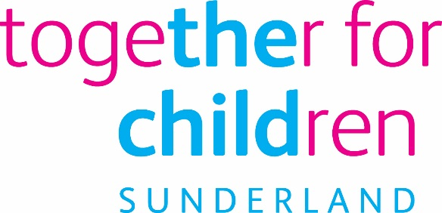
Job Description
Job Title: Business Support Assistant
Salary Grade: Grade 2
SCP: 15 - 17
Job Family: Business Support
Job Profile: BS3
Directorate: Corporate and Commercial services (Children’s Independent Review Team)
Work Environment: Office Based/ Agile
Reports to: Business & Administration Manager
Number of Reports: NA
Your normal place of work will be work at any Company recognised workplace.

This position requires an Enhanced Disclosure and Barring Service (DBS) Check.

Purpose:
To provide administrative support to a busy IRO team within Together For Children (TFC)

To maintain good records and possess a sound technical knowledge of developed IT systems, statutory procedures, legislation, corporate standards and policies.

Some transactional functions may be required, for example dealing with petty cash, processing invoices or inputting financial data for service areas.

To attend and minute Child Protection Conferences and other meetings as required, producing accurate sets of minutes and other relevant meeting documents within agreed timescales, liaising with the chairperson to amending minutes accordingly.

To distribute approved meeting documents as required.

To be able to work in a variety of locations covering different function as required by the IRO Business & Administration Manager or the IRO Managers.

Key Responsibilities:
- Categorise and organise activities in line with the priorities provided by the IRO Business & Administration Manager
- Analyse data, using given parameters or business rules, to provide conclusions or determine the appropriate service provision.
- Provide detailed, relevant and accurate information and support to customers and colleagues to inform decision making and support the efficient running of the service.
- Escalate complex issues to the IRO Business & Administration Manager or IRO Managers as appropriate.
- Create and amend data using automated software of standard templates to meet data management and service monitoring requirements.
- Attend meetings in order to produce accurate minutes, ensure that appropriate discussions are documented and liaise with the meeting chair to approve the minutes accordingly, making suggested amendments as required.
- Update and produce relevant meeting documents within Management Information System or appropriate templates.
- Distribute meeting minutes and documents.
- Ensure that TFC’s management information system is accurate and all information recorded timely.
- Provide an overall administrative support via a range of tasks to the Children’s Independent Review Team.
- May be required to work in a variety of locations as required by the IRO Business & Administration Manager or IRO Managers depending on the needs of the service

C. Additional Information/Other Requirements

- Other duties and responsibilities allocated which are appropriate to the grade of this post.
- The post will be based within TFC’s Performance and Quality Directorate.
- The post holder will be required on occasion to travel within the City as required to undertake the role.
- The post will report to the Business Manager

Statutory requirements:
In line with the Together for Children’s Statutory Requirements, all employees should:
Comply with the principles and requirements of the General Data Protection Regulation (GDPR) in relation to the management of Together for Children Sunderland’s records and information, and respect the privacy of personal information held by Together for Children Sunderland.
Comply with the principles and requirements of the Freedom in Information Act 2000;
Comply with the Together for Children Sunderland’s information security standards, and requirements for the management and handling of information;
Undertake the duties of the post in accordance with the Company’s Equal Opportunities Policy, Health and Safety Policy and legislative requirements and all other Company policies.
This position is a politically restricted post as identified by Together for Children and in accordance with The Local Government and Housing Act 1989 (LGHA).

Author: Gavin Taylor / Heather Sutherland
Date: April 2021

Essential Requirements

Qualifications:  - NVQ Level 2 in Business Administration or equivalent qualification or experience. | Application form/Pre-employment checks
Experience of :  - Experience of working in a fast pasted administrative environment.  - Experience of working in customer facing role.  - Experience of working to tight deadlines and managing own workload to achieve targets.  - Experience of minute taking. | Application Form I
Knowledge and understanding of:  - Knowledge of full range of Microsoft Office package  - Ability to record accurate meeting minutes/notes based on discussions. | Application form/Interview  Test
Ability to:  - Able to share information and obtain information from others through written/verbal communications.  - Listens to others to assess requirements in order to respond appropriately and efficiently  - Able to effectively use a PC to prepare documents, reports, record information or input data | Application form Interview  Test
Commitment to Equal opportunities | Interview

Author: Gavin Taylor / Heather Sutherland
Date: April 2021

