Atkinson House School
Office Manager

Published: 5 July 2019
Closing Date: 9:00am, 12 July 2019
Salary: Band 6, plus 10 days
Required for: 1st September 2019
From September there is an exciting opportunity to join our Administration Team as Office Manager. We aim to appoint an Office Manager who will lead the Office, support the governing body and whole staff, as well as understanding and supporting students who have Social and Emotional Mental Health needs. We are looking for an experienced practioner who has a range of skills and experiences and who can join and compliment the new team.

Atkinson House remains Northumberland County Council’s only designated provision for pupils aged 11 – 19, with Social, Emotional and Mental health (SEMH). The school has always been designated to cater for boys and young men who travel into school from all over Northumberland. Our mission is to provide a high quality educational community which offers life-changing opportunities in a safe, creative and exciting environment.
Applications are invited from outstanding practitioners who has brilliant orgainastional and communicational skills, who is solution-focused, works calmly under pressure and who forms positive relationships with all stakeholders, including our students. You must also be able to demonstrate recent, successful impact within your current role.

The successful applicant will benefit from significant support from our Head Teacher and Leadership Team. A personalised CPD package will be provided to support your transition into the school.

Office Manager

Organisation

- Take a lead role in planning, development, design, organisation and monitoring of support systems/procedures/policies
- Line Management responsibilities in relation to school administrative staff
- Manage the day-to-day work of school administrative staff
- Liaise between managers / teaching staff and support staff
- Holds team meetings with managed staff as required.
- Undertake recruitment/induction/appraisal/training/mentoring for other staff
- Be involved in the recruitment of other administrative staff
- Deal with administrative tasks relating to recruitment matters

Administration

- Take a lead role in the development and maintenance of record/information systems
- Provides data/ and produce detailed reports/information as required
- Produce, and respond to, complex correspondence
- Provide organisational and administrative support to other staff
- Provide organisational and complex advisory support to the Governing Body (if required by the school)
- Manage complex administrative procedures
- Be responsible for completion and submission of complex forms, returns etc., including those to outside agencies e.g. DfE
- Manage school lettings
- Organise and monitor progress towards premises repairs
- Manage the administration of the payroll system (if required by the school)

Resources

- Be responsible for the selection and management of resources, including management of a budget and regular audit of resources
- Be involved in the recruitment of administrative staff
- Provide administrative support in relation to recruitment and employment matters
- Provide advice and guidance to staff and others on complex administrative issues
- Undertake research and obtain information to inform decisions
- Take a lead role in procurement and securing sponsorship/funding
- Manage service contracts
- Manage school licences and insurance
- Take a lead role in promoting the school
- Manage facilities including premises, lettings and associated income, building and projects etc.
- Manage financial administration procedures
- Contributes to the monitoring and evaluation of budget
- Be responsible for the management of expenditure within an agreed budget
- Be aware of health and safety issues in relation to display screen equipment and office practice

Responsibilities

- Comply with policies and procedures relating to child protection, health, safety and security, confidentiality and data protection, reporting all concerns
- to an appropriate person
- Assist with the development of policies relating to confidentiality and data protection
- Be aware of and support difference and ensure equal opportunities for all
- Contribute to the overall ethos/work/aims of the school
- Develop constructive relationships and communicate with other agencies/professionals
- Share expertise and skills with others
- Participate in training and other learning activities and performance development as required
- Recognise own strengths and areas of expertise and use these to advise and support others
- To undertake other duties and responsibilities as required commensurate with the grade of the post

Atkinson House School. sets high expectations for staff and learners in order to meet our mission and raise standards. We safeguard and protect our students and staff by being committed to respond in accordance with Local Safeguarding Board Procedures.

This posts are exempt from the rehabilitation of Offenders Act 1974 and therefore will be subject to a criminal record check from the Disclosure and Barring Service.

We are committed to safeguarding and promoting the welfare of children and young people and expect all staff to share this commitment. An enhanced criminal records check is required for this post.

Further information about the school can be found on our website.

An application pack, including an application form, is available by telephoning the school office, quoting the website vacancy number

Letters of application, (outlining the post(s) you are applying for, what skills and experiences you have to date that will make you the ideal appointment and why you want to work at Atkinson House School) along with completed application forms should be returned directly to the school by post and/or by e-mail, no later than 9am on Monday 15 July 2019. Successful shortlisted candidates will be contacted individually to inform them of their interview which will be held on Wednesday 17 July 2019.

School Name: Atkinson House School
Full address: Pitt Lane, Front Street, Seghill.
Postcode: NE23 7EB
Tel.: 0191 2980838
e-mail: admin@atkinson.house
Website address: Atkinsonhouse@northumberland.sch.uk

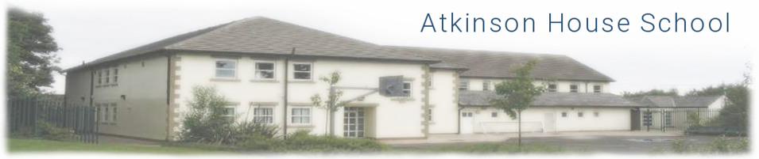

Welcome to Atkinson House…

Atkinson House School first opened in September 2000, and we remain Northumberland County Council’s only designated provision for pupils aged 11 – 19, with Social, Emotional and Mental Health (SEMH). The school has always been designated to cater for boys and young men who travel into school from all over Northumberland. The whole ethos of the schools is based on care, responsibility and proactive behaviour management, where mutual respect is of prime importance.

The singularity of vision shared by staff enables us to provide the highest quality education and support for all our pupils. Indeed, staff will always go ‘the extra mile’ to create a caring environment in which young people are encouraged to manage and overcome their difficulties within a climate that promotes curiosity and learning; enabling them to be the best they can be. Our high expectations empower pupils to make outstanding progress academically, morally and socially. In addition, we focus on their place in the community, encouraging their development into active and responsible members of society.

The website will give you some information about what we offer but the best way to get a ‘feel’ for Atkinson House School is to come and see for yourselves. Please do get in touch to arrange a tour if you would like to come and see the school for yourself.

Should you decide that this post and that Atkinson House School is the right school for you then we would welcome your application by 9:00am on Monday 15 July 2019. We ask that you complete the attached Application Form and write a letter, no more than two-sides of A4 outlining:
- Your experiences to date and how they meet the job description; and
- What will you bring to the role of Office Manager that sets you out to be the best person for the post at Atkinson House School.

We wish you well and look forward to hearing from you.

W P Sampson
Head Teacher

