Durham County Council

Apprenticeship Information Pack

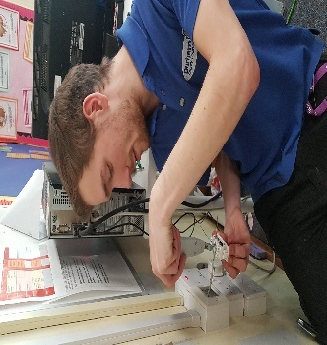
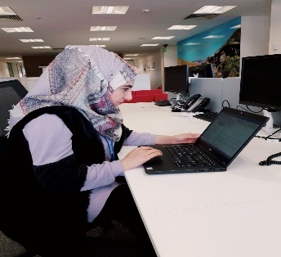

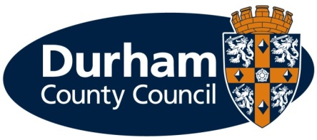
What is an apprenticeship?

Apprenticeships are an excellent option for all ages. An apprenticeship is a genuine job where you will receive formal training to gain a recognised qualification alongside gaining technical knowledge, practical experience and wider skills you need for employment and a future career.

What types of apprenticeships are available?

Durham County Council provides the majority of local council services in the county. The council offers a huge range of job opportunities and a wide range of apprenticeships are also available including catering, accounting, construction and business administration to name a few. We have the career to meet your aspirations. Further information on the council’s services can be found on our website at www.durham.gov.uk

We are pleased to be offering the following apprenticeship for a October 2019 start:

Service | Apprenticeship | Length of Apprenticeship | Location | Training | Training Provider
Resources – Digital and Customer Services | 2 x Apprentice | 2 years | Crook Civic Centre | Customer Services Level 2 or 3 | Adult Learning & Skills Service
What are the different levels of apprenticeship?

There are a range of apprenticeships at different levels including:

- Intermediate level apprenticeship (Level 2) – equivalent to five GCSE passes
- Advanced level apprenticeship (Level 3) – equivalent to two A level passes
- Higher apprenticeship (Level 4 and 5) – can lead to a higher national certificate (HNC) or a foundation degree
- Degree apprenticeship (Level 6 and 7) – can lead to the achievement of a full bachelor’s or master’s degree

How much will I earn?

This will depend on the type of apprenticeship you are doing.

If you are working towards a Level 2, 3 or 4 qualification during the term of your apprenticeship (excluding craft apprenticeships) you will be paid:

- £3.90 per hour for the first year of your apprenticeship
- If you are aged 19 years or over and have completed the first year of your apprenticeship you will then be paid:
  - 19 to 20 year old £6.15 per hour
  - 21 to 24 year old £7.70 per hour
  - 25+ years £8.21 per hour
(Rates effective from 1 April 2019)

If you are working towards a Level 5, 6 or 7 qualification during the term of your apprenticeship you will be paid the rate outlined in the job advert.
You will be paid on the last working day of each month, with the money paid directly into your bank account.

Your apprenticeship training will be fully funded by the Council.

What should I expect from an apprenticeship at the council?

- A workplace induction to help you understand your role and the council
- A structured work programme working alongside experienced employees
- Ability to study towards a recognised qualification
- Regular review meetings with your manager
- A workplace mentor
- Opportunities to undertake work based and off the job training
- Access to a range of training opportunities
- Support to help you apply for jobs
- To be part of an Apprenticeship Network where you will receive updates of what is happening across the council including any training or job opportunities available, build a network of support, be able to discuss support/information required and put forward ideas for improvements.
- Working in an environment that promotes an inclusive and diverse workforce.

What are the additional benefits of working for the council?

- Holiday entitlement
- Pension
- A range of flexible working options, some depending on job role
- Maternity, paternity, dependency and adoption leave
- Sickness pay

How do I apply?

If you are not already registered you will need to register with North East Recruitment Portal and apply online at https://www.northeastjobs.org.uk/default.aspx?page=orghome&orgid=73 Click on the apprenticeship job category to see the opportunities available.

Key dates

Applications | Online applications close on 13th October 2019
Shortlisting | Takes place on 14th October 2019
Interviews | Take place 24th & 25th October 2019

If you require any reasonable adjustments at the application or selection stage, please contact Peter Brockman, Senior Resources and Development Officer (Organisational Workforce Development Team) on Tel: 03000 268 547 or via email (peter.brockman@durham.gov.uk)

If you are shortlisted you will receive notification of the date and time of your interview via an e-mail from North East Recruitment Portal.

Additional Support

As a disability confident employer, we welcome applications from people with disabilities and as an inclusive employer we recognise the importance and benefits of having an inclusive and diverse workforce. To ensure we can offer the best possible support for applicants, we will pro-actively make reasonable adjustments within the recruitment and selection process for disabled people.

The range of reasonable adjustments that can be accommodated throughout the selection process include (but is not exhaustive):

- Alternative formats for job applications
- More detailed/pictorial instructions for interview
- Support from an appropriate person at the interview
- Additional time to complete applications (and or tests) where appropriate.
- Adjustments to interview venue/accommodation
- Adjustments to method of testing
- Adjustments to interview questions e.g. receiving questions in advance

Please contact Peter Brockman, Senior Resources and Development Officer, Organisational Workforce Development Team on Tel: 03000 268 547 or via email (peter.brockman@durham.gov.uk) to discuss any reasonable adjustments in more detail. This will ensure you get the appropriate support during the recruitment and selection process.

In addition to reasonable adjustments, the council also provide a ‘guaranteed interview scheme’ which allows people with disabilities to be shortlisted where they demonstrate they can meet the essential criteria of the role.

What happens if I am unsuccessful?

If you have been unsuccessful with your application to a role at Durham County Council, we would like to support you as much as possible with reviewing your options. Therefore;

- If you are unemployed and between 18-24 live in County Durham and would like support with education or training, please e-mail: durhamworks@durham.gov.uk or telephone: 0300 026 2930 for further information, support, advice and guidance.

- If you are 19 years of age and older you can also access support, information, advice and guidance or access accredited qualifications on a formal or flexible basis through our Adult Learning and Skills Service (ALSS). From more information or to speak to one of our engagement team, please contact us by emailing alss@durham.gov.uk or telephone: 03000 266 115.

There are no restrictions, in terms of accessing this service, and we would treat each enquiry on an individual basis.

We look forward to hearing from you.

