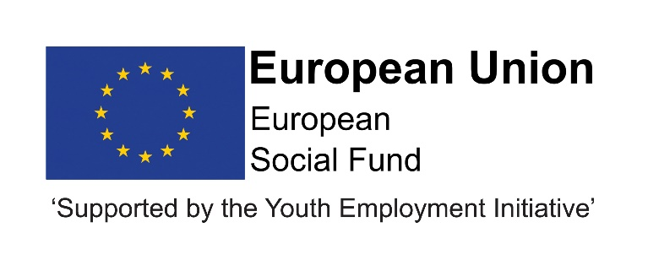

Job Description
Post title | Tracking and Engagement Worker
JE Reference No | N10325
Grade | Grade 4
Service | Children and Young People’s Services
Service Area | Education & Skills - Progression & Learning
Reporting to | Progression Team Leader
Location | Your normal place of work will be an agreed team location, but you may be required to work at any Council workplace within County Durham.
DBS | This post is subject to an enhanced disclosure.
Flexitime | This post is eligible for flexitime.
Politically restricted | This post is not designated as a politically restricted post in accordance with the requirements of Section 1(5) of the Local Government and Housing Act 1989 and by regulations made from time to time by the Secretary of State.

Relevant to this post | This post is funded through ESF and the Youth Employment Initiative (YEI) as part of the 2014-2020 European Structural and Investment Funds Growth Programme in England. This is referred to as; the ESF DurhamDirections and DurhamWorks project and is initially funded until June 2022 with the possibility of further extension, dependent upon approval of funding.

Description of role

The role of Tracking and Engagement Worker is to support the Local Authority to meet its statutory obligations in relation to the participation of young people in Education, Employment and Training. The Tracking and Engagement Worker will assist the Progression Advisors and Progression Workers to ensure management information and reporting requirements are fully met to allow young people to maximise their potential.

Duties and responsibilities

Listed below are the responsibilities this role will be primarily responsible for:

- To make and receive telephone calls to young people and/or their parents or carers to gather information, making decisions about the response required.
- To conduct home visits to young people and their families to gather information and make decisions about the response required and referrals to colleagues.
- To utilise effective strategies and creative approaches to engage with harder to reach young people and refer on to the appropriate colleague within the service
- To accurately maintain and update client records using the Local Authority CCIS, including all interventions, follow-ups and destinations, in order to contribute to accurate Management Information.
- To promote the service and engage young people in activities such as open events, drop in sessions, community activities.
- To track young people, in order to identify those who require support and those who require further information gathering, in line with procedures.
- To manage incoming calls and emails.
- To work directly with young people in a supportive role and assist the Progression Workers and Progression Advisers in the delivery of quality youth work activities which improve outcomes for young people.
- To take responsibility for managing high volumes of data input and information gathering working to tight deadlines.
- To engage young people in effective dialogue in order to review and improve Service delivery.
- To ensure effective information sharing with colleagues within appropriate timescales
- To ensure information is processed within statutory timescales to meet reporting requirements.
- To work in the interests of young people through challenging stereotypes and promoting equal opportunities.
- To support information management and report production in relation to participation in learning e.g. statistical data etc.
- To work within current Data Protection requirements, Information Sharing protocols and Caldicott Guidelines.
- To ensure effective safeguarding and child protection arrangements, in line with Durham County Council policy and guidelines.
- To work in line with Durham County Council policies and procedures.
- To meet own professional development needs by attending appropriate training courses and undertaking self-directed study, as identified through support and supervision, annual appraisal etc.

Organisational responsibilities

- Values and behaviours
To demonstrate and be a role model for the council’s values and behaviours to promote and encourage positive behaviours, enhancing the quality and integrity of the services we provide.

- Smarter working, transformation and design principles
To seek new and innovative ideas to work smarter, irrespective of job role, and to be creative, innovative and empowered. Understand the operational impact of transformational change and service design principles to support new ways of working and to meet customer needs.

- Communication
To communicate effectively with our customers, managers, peers and partners and to work collaboratively to provide the best possible public service. Communication between teams, services and partner organisations is imperative in providing the best possible service to our public.

- Health, Safety and Wellbeing
To take responsibility for health, safety and wellbeing in accordance with the council’s Health and Safety policy and procedures.

- Equality and diversity
To promote a society that gives everyone an equal chance to learn, work and live, free from discrimination and prejudice and ensure our commitment is put into practice. All employees are responsible for eliminating unfair and unlawful discrimination in everything that they do.

- Confidentiality
To work in a way that does not divulge personal and/or confidential information and follow the council’s policies and procedures in relation to data protection and security of information.

- Climate Change
To contribute to our corporate responsibility in relation to climate change by considering and limiting the carbon impact of activities during the course of your work, wherever possible.

- Performance management
To promote a culture whereby performance management is ingrained and the highest of standards and performance are achieved by all. Contribute to the council’s Performance and Development Review processes to ensure continuous learning and improvement and to increase organisational performance.

- Quality assurance (for applicable posts)
To set, monitor and evaluate standards at individual, team and service level so that the highest standards of service are delivered and maintained. Use data, where appropriate, to enhance the quality of service provision and support decision making processes.

- Management and leadership (for applicable posts)
To provide vision and leadership to inspire and empower all employees so they can reach their full potential and contribute to the council’s values and behaviours. Managers and leaders must engage in personal development to ensure they are equipped to lead transformational change; always searching for better ways to do things differently to meet organisational changes and service priorities.

- Financial management (for applicable posts)
To manage a designated budget, ensuring that the service achieves value for money in all circumstances through the monitoring of expenditure and the early identification of any financial irregularity.

The above is not exhaustive and the post holder will be expected to undertake any duties which may reasonably fall within the level of responsibility and the competence of the post as directed by your manager.

Person specification
 | Essential | Desirable
Qualifications | - Level 2 qualification in Youth Work or a related discipline. | - Information, Advice and Guidance Qualification.
Experience | - Experience of working with young people, their parents/carers and other professionals.  - Experience of providing information and support to young people.  - Experience of delivering group work or one-one interventions with young people which have resulted in successful engagement on a particular programme.  - Experience of working with databases  - Experience of working in the community delivering activities which have led to engagement with services. | - Experience of working with a range of partners and organisations.
Skills & Knowledge | - Ability to communicate effectively with a range of different individuals and in a range of different settings  - A person-centred, empathetic and non-judgemental approach to working with young people.  - Ability to work to tight timescales  - Ability to work autonomously and use own initiative  - Ability to work as part of a team and offer assistance to colleagues  - Ability to use ICT including Outlook and Microsoft Office.  - Good organisational skills.  - Ability to prioritise and manage workload
Personal Qualities | - Open, friendly and supportive with a genuine interest in supporting young people to progress.  - Hold high aspirations for young people.  - Personal resilience.  - Commitment to high quality service delivery.  - Willingness to work across a large geographical area which will involve travel to and from various locations  - Adaptability, flexibility and capacity to work effectively to tight deadlines.  - Ability to work under direction and to use own initiative when appropriate.  - Ability to work as part of a team making active contributions to support its success.  - Willingness to undertake ongoing professional development.  - Commitment to Equal Opportunities.  - Self- motivated
Other qualities | - Access to a car or means of mobility support (if driving, must hold a full current UK driving licence and appropriate insurance).  - Willingness to occasionally work unsocial hours as required, including evenings and weekends.

