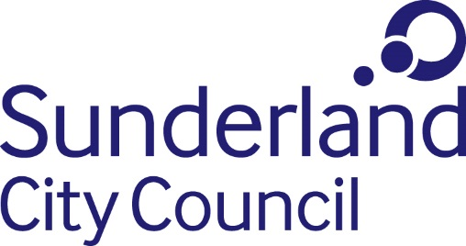
Job Description

Job title: Media Relations Executive
Directorate: People, Communications and Partnerships
Grade: Grade 2 / Grade 4 (Salary in accordance with experience)
Responsible to: Media Relations Manager

Purpose:
- To support the Media Relations Manager to provide expert advice and delivered co-ordinated PR strategies that enhance and protect the council’s reputation.
- To support the development and delivery of communications campaigns which showcase work across the Council to provide vital services to residents and business.

Main Duties and Responsibilities:
- Deliver engaging PR activity which increase the visibility and understanding of the council’s work with key audiences with a focus on digital and social media.
- To work within the wider communications team and alongside colleagues in other teams across the Council, businesses, partners and suppliers such as design agencies and PR consultancies.
- Organise media events and interview, filming and photo opportunities.
- Support the Media Relations Manager in managing the media in crisis situations, working with partner organisations to deliver reactive and timely PR, as well as media presence at large scale events such as Sunderland Airshow and elections.
- Support the Media Relations Manager in handling major issues affecting the reputation of the City Council.
- Contribute to a forward plan of PR opportunities,
- Evaluate and measure activity and use as a tool for planning future work.
- Have a good understanding of the media, communications and marketing landscape, particularly in terms of digital channels and content.
- To work across different projects and issues at any one time.
- To work across a large and dynamic organisation as it aims to deliver an ambitious City Plan and grow its reputation.
- Deliver required PR activity around key events for the council and city.
- Be a visible and enthusiastic team member, encouraging partnership working across the organisation and with key partners for the council.
- To promote and champion a positive organisation-wide culture that reflects the Council’s values.
- Comply with the principles and requirements of the Data Protection Act 2018 and GDPR in relation to the management of Council records and information, and respect the privacy of personal information held by the Coucil.
- Comply with the principles and requirements of the Freedom of Information Act 2000
- Comply with the Council’s information security standards, and requirements for the management and handling of information; Use Council information only for authorised purposes.
- Carry out duties with full regard to the Council’s Equality policies, Code of Conduct and all other Council policies.

Comply with the Council’s Health and Safety policy, rules and regulations and with Health and Safety legislation.

Comply with the principles and requirements in relation to the management of Council records and information; respect the privacy and personal information held by the Council.

September 2019

