Durham County Council

Apprenticeship Information Pack

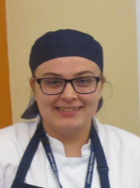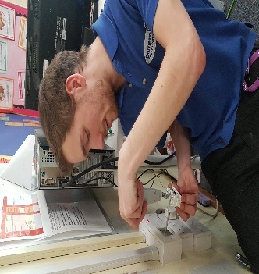
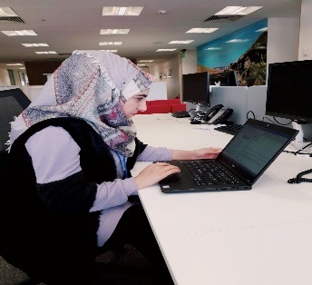

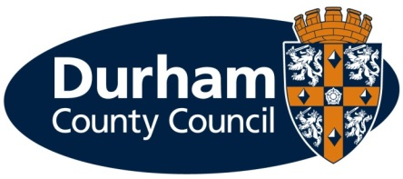
What is an apprenticeship?

Apprenticeships are an excellent option for all ages. An apprenticeship is a genuine job where you will receive formal training to gain a recognised qualification alongside gaining technical knowledge, practical experience and wider skills you need for employment and a future career.

What types of apprenticeships are available?

Durham County Council provides the majority of local council services in the county. The council offers a huge range of job opportunities and a wide range of apprenticeships are also available including catering, accounting, construction and business administration to name a few. We have the career to meet your aspirations. Further information on the council’s services can be found on our website at www.durham.gov.uk

We are pleased to be offering the following apprenticeship for a September 2019 start:

Service | Apprenticeship | Length of Apprenticeship | Location | Training | Training Provider
Adult & Health Services – Adult Care | 2 x Apprentice (Adult Care Worker) | 2 years | County Hall, Durham | Adult Care Worker Level 2 | Adult Learning & Skills Service

What are the different levels of apprenticeship?

There are a range of apprenticeships at different levels including:

- Intermediate level apprenticeship (Level 2) – equivalent to five GCSE passes
- Advanced level apprenticeship (Level 3) – equivalent to two A level passes
- Higher apprenticeship (Level 4 and 5) – can lead to a higher national certificate (HNC) or a foundation degree
- Degree apprenticeship (Level 6 and 7) – can lead to the achievement of a full bachelor’s or master’s degree

How much will I earn?

This will depend on the type of apprenticeship you are doing.

If you are working towards a Level 2, 3 or 4 qualification during the term of your apprenticeship (excluding craft apprenticeships) you will be paid:

- £3.90 per hour for the first year of your apprenticeship
- If you are aged 19 years or over and have completed the first year of your apprenticeship you will then be paid:
  - 19 to 20 year old £6.15 per hour
  - 21 to 24 year old £7.70 per hour
  - 25+ years £8.21 per hour
(Rates effective from 1 April 2019)

If you are working towards a Level 5, 6 or 7 qualification during the term of your apprenticeship you will be paid the rate outlined in the job advert.
You will be paid on the last working day of each month, with the money paid directly into your bank account.

Your apprenticeship training will be fully funded by the Council.

What should I expect from an apprenticeship at the council?

- A workplace induction to help you understand your role and the council
- A structured work programme working alongside experienced employees
- Ability to study towards a recognised qualification
- Regular review meetings with your manager
- A workplace mentor
- Opportunities to undertake work based and off the job training
- Access to a range of training opportunities
- Support to help you apply for jobs
- To be part of an Apprenticeship Network where you will receive updates of what is happening across the council including any training or job opportunities available, build a network of support, be able to discuss support/information required and put forward ideas for improvements.
- Working in an environment that promotes an inclusive and diverse workforce.

What are the additional benefits of working for the council?

- Holiday entitlement
- Pension
- A range of flexible working options, some depending on job role
- Maternity, paternity, dependency and adoption leave
- Sickness pay

How do I apply?

If you are not already registered you will need to register with North East Recruitment Portal and apply online at https://www.northeastjobs.org.uk/default.aspx?page=orghome&orgid=73 Click on the apprenticeship job category to see the opportunities available.

Key dates

Applications | Online applications close on 19 August 2019
Interviews | Take place w/c 2nd September 2019

If you require any reasonable adjustments at the application or selection stage, please contact Peter Brockman, Senior Resources and Development Officer (Organisational Workforce Development Team) on Tel: 03000 268 547 or via email (peter.brockman@durham.gov.uk)

If you are shortlisted you will receive notification of the date and time of your interview via an e-mail from North East Recruitment Portal.

Additional Support

As a disability confident employer, we welcome applications from people with disabilities and as an inclusive employer we recognise the importance and benefits of having an inclusive and diverse workforce. To ensure we can offer the best possible support for applicants, we will pro-actively make reasonable adjustments within the recruitment and selection process for disabled people.

The range of reasonable adjustments that can be accommodated throughout the selection process include (but is not exhaustive):

- Alternative formats for job applications
- More detailed/pictorial instructions for interview
- Support from an appropriate person at the interview
- Additional time to complete applications (and or tests) where appropriate.
- Adjustments to interview venue/accommodation
- Adjustments to method of testing
- Adjustments to interview questions e.g. receiving questions in advance

Please contact Peter Brockman, Senior Resources and Development Officer, Organisational Workforce Development Team on Tel: 03000 268 547 or via email (peter.brockman@durham.gov.uk) to discuss any reasonable adjustments in more detail. This will ensure you get the appropriate support during the recruitment and selection process.

In addition to reasonable adjustments, the council also provide a ‘guaranteed interview scheme’ which allows people with disabilities to be shortlisted where they demonstrate they can meet the essential criteria of the role.

What happens if I am unsuccessful?

If you have been unsuccessful with your application to a role at Durham County Council, we would like to support you as much as possible with reviewing your options. Therefore;

- If you are unemployed and between 18-24 live in County Durham and would like support with education or training, please e-mail: durhamworks@durham.gov.uk or telephone: 0300 026 2930 for further information, support, advice and guidance.

- If you are 19 years of age and older you can also access support, information, advice and guidance or access accredited qualifications on a formal or flexible basis through our Adult Learning and Skills Service (ALSS). From more information or to speak to one of our engagement team, please contact us by emailing alss@durham.gov.uk or telephone: 03000 266 115.

There are no restrictions, in terms of accessing this service, and we would treat each enquiry on an individual basis.

We look forward to hearing from you.

Overview of the service area:

Adult & Health Services - County Durham Care & Support, in-house provider services across County Durham

Following a care assessment from a Social Worker / Care Coordinator, a care plan will identify the persons needs. CDC&S develops a person-centered care and support plan that will meet / deliver the identified needs. CDC&S is generally perceived a provider of high dependency Care and Support for people aged 16 upwards.

- Extra Care – Extra Care offers older people with eligible care and support needs an alternative to moving into a care home. Services are delivered based on a home care arrangement helping people to live independently as possible. People have their own flat in specially designed housing complex with 24-hour care and support on site. There are 7 locations throughout Durham.
- Shared Lives – The scheme is generally available to people with a learning disability who have been assessed as needing short breaks, long term placements or emergency support. Care takes place in the family home of a shared lives provider. Shared lives provide a safe and secure home that supports a person’s rights and independence, whilst encouraging learning and development of skills. There are over 40 providers across the County.
- Pathways – A specialist service meeting complex care needs. The service provides a safe, stable and enjoyable environment that enables people to challenge perception and to flourish. There are 5 Pathways Hubs across the county, 3 hubs are based in leisure centres and 2 in purpose-built venues. All hubs have a bright, warm and welcoming atmosphere. Each hub has state of the art equipment and resources, including interactive Magic Carpets, regularly up-dated education programmes, sensory activities and a wide range of activities and events taking place regularly.
- Hawthorn House – Provides respite to people with a learning disability, in a specially designed building 24 hours per day, 7 days per week. People can come in for a day or a longer period, the service supports emergency places and works very closely with families to ensure stays are truly personal.
- Support and Recovery – S&R is a service that works with people who have a mental health issue to help them recover and lead the kind of life they want. The service works with people to find out what they want from support and what goals they want to achieve. When goals have been realised, S&R will help support people to move on from the service by reviewing their achievements and encouraging them to keep up with all the activities and coping strategies they have been doing to help them recover.

