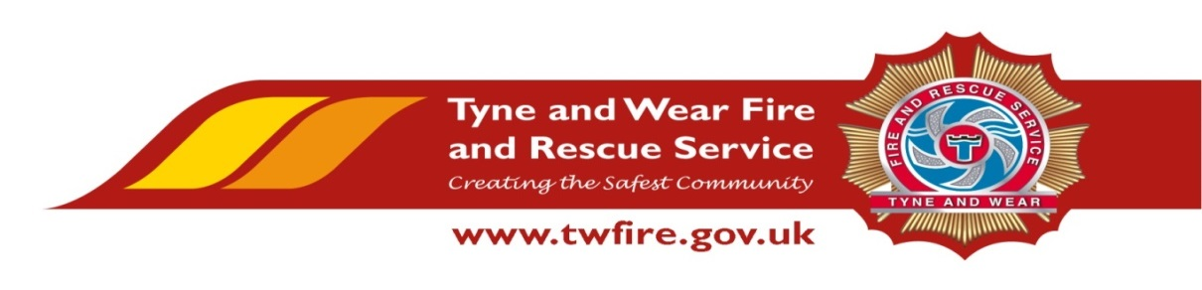

Risk and Information Assistant
Starting salary of £18,795 + Benefits

We have an exciting opportunity for a talented and experienced Administrative Assistant.

Under the guidance of the Risk Team Manager you will support the delivery of a range of administrative duties within the function which contribute to the provision of an excellent service, whilst ensuring the effective use of resources.
The Service values and respects the diversity of its employees, and aims to recruit a workforce that represents the communities we serve. We welcome applications irrespective of people’s race, disability, gender, sexual orientation, religion or belief, age, gender identity, marriage and civil partnership, pregnancy and maternity.

Required Skills/Experience:
- An experienced administrator with the ability to undertake a wide range of duties using databases and recording systems.
- Experience of preparing comprehensive reports and working with statistical information.
- Proven experience in diary management, minute taking and time management.
- Able to work on own initiative, demonstrating organisational skills.

What we can offer you
Tyne and Wear Fire and Rescue Service Headquarters are based in a purpose build office in Washington, with ample free parking and easy access from the A1 and A19. On site facilities include catering facilities and an onsite gym. The role also benefits from an attractive package, including up to 22 days holiday and public holidays, Local Government Pension Scheme and access to a range of social and volunteering opportunities.

Closing Date: Tuesday 20 August 2019

Interviews: Week Commencing 26 August 2019
